**A Project Report on**

**FARMERS ORGANI STORE**

**USING HTML & CSS**

submitted by

**PERLA BHAVANA - GQT-S0152**

under the mentorship of

**KESHAV MURTHY**



**GLOBAL QUEST TECHNOLOGIES**

[info@gqtech.in](mailto:info@gqtech.in)

Yelahanka Satellite Town,

Bangalore, Karnataka - 560064.

[2023]

|  |  |
| --- | --- |
| **Signature of the mentor** | **Signature** |
|  |  |
| **Keshav Murthy** | **G.R.Narendra Reddy** |

**INTRODUCTION**

**HISTORY OF HTML:**

**HTML** stands for **Hyper Text Markup Language**.

* It is used to share the information over the internet.
* HTML id developed by Tim Berner’s Lee in 1991.But officially in 1993.
* The First version of HTML consists of “18 tags”
* HTML follows certain rules and regulations setup by “**ISO**”.
* International Organization for standardization is set of rules and regulation are present in ‘**SGML**’ document.

**Versions of HTML**

* **HTML-1** version in the year 1993.
* **Html-2** version in the year 1995.
* **HTML-3.02** version in the year 1997.
* **HTML-4.1** version in the year 1999.
* **HTML-5** version in the year 2014.

**Features of HTML**

* It is easy to Learn.
* It is a tag based language.
* HTML is supported by multiple browsers.
* First web browser is Netscape navigation which was developed by the “Mosiac”.
* It is a portable language.
* **WORA** stands for ‘write once run anywhere’

**Limitation of HTML**

* HTML has less designing capabilities.
* It is dependent on other technology such as CSS in order to develop well designed Webpages.
* HTML has no programming capabilities.
* Using HTML and CSS we can develop only static Web page.
* In order to write the HTML code required an editor such as VS Code, Notepad, Eclipse.
* In order to execute the HTML code we required Web browsers.Like Chrome, Firefox, edge, Opera Safari .

**CSS**

* **CSS** stands for **Cascading Style Sheets**.
* It was developed by W3C to add stylings to the HTML elements.
* W3C stands for World Wide Web.com

**Versions of CSS:**

* CSS-1 (level-1) in the year 1996.
* CSS-2 (level-2) in the year 1998.
* CSS-3 (level-3) in the year 1999.

**Why do we required CSS ?**

* Since HTML has less designing capabilities we cannot create well designed or most appealing Websites.
* Using HTML we cannot add style, animation and transitions to the Webpage.
* Therefore we require CSS to create well designed Webpages.

**Advantages of CSS**

* It allows to add styles, animation and variouses effects to the Webpage.
* It allows us to develop the Webpage rapidly. It is also know as RAD ( rapid application Developer).
* It allows us to separate from formatting develop page to the presentation of Webpage.
* It allows to create well designed Websites.

**Limitations of CSS**

* Using CSS we can perform static styles for the Webpages.
* In order to create dynamic styling for the Websites. We must make use of scripting language such as JavaScript and Libraries of JavaScript.

**Types of CSS:**

1. Inline CSS
2. Internal CSS
3. External CSS
4. Default Browser CSS

**Inline CSS:**

Defining all the CSS properties within the style attribute inside the opening of the tag is referred to as Inline CSS.

**Internal CSS:**

Defining all the CSS properties within <style> inside the HTML document is referred to as Internal CSS.

**External CSS:**

Defining all the CSS properties within as external Script or File with an extension CSS is referred to as External CSS.

* In order to link external CSS file within the HTML document we must use of <link>.
* The value for the ‘ref’ attribute should be ‘stylesheet’.

**FARMERS ORGANIC STORE**

**Scope of the document**

The scope of a project to establish an organic store using the "Formers" name (assuming Formers is a brand or concept) would typically involve defining the objectives, deliverables, tasks, and constraints associated with this venture. Below is a general outline of the project scope for an organic store project using the name "Formers"

**Technologies Used**

* HTML5
* CSS3

**Our Project**

**Root Structure:**

**Farmers Organi Store**

**→CODES**

**→HTML_Files**

→Farmers.html

→Vegitables.html

→Sample.html

→Fruits.html

→Leafy.html

→DryFruits.html

→Spices.html

→DryFruits.html

→Flowers.html

→Login.html

**→CSS_Files**

→Farmers.css

→Vegitables.css

→sample.css

→Fruits.css

→Leafy.css

→spices.css

→Dryfruits.css

→flowers.css

**PROJECT REPORT**

→FRONT END PROJECT 2 FARMARS.DOC

**SCREENSHOTS**

→ALL THE CORRESPONDING SCREENSHOTS OF PAGES.

**CONTROL FLOW DIAGRAM:**

VEGITABLES. HTML IS OPENED

**Click**

SMAPLES.HTML IS OPENED

**Click**

**Click**

FRUITS.HTML IS OPENED

**Click**

LEAFY.HTML IS OPENED

**Click**

DRYFRUITS.HTML IS OPENED

SPICES.HTML IS OPENED

**Click**

**Click**

FLOWERS.HTML IS OPENED

**Source Code:-**

**Farmers.html**

<!DOCTYPE html>

<html lang="en">

<head>

    <meta charset="UTF-8">

    <meta name="viewport" content="width=device-width, initial-scale=1.0">

    <title>Document</title>

    <link rel="stylesheet" href="Farmers.css" >

    <style>

        *{

            margin: 0px;

            box-sizing: border-box;

        }

        #a{

            height: 350px;

            background-color:rgb(3, 94, 3);

        }

        .v{

            color:white;

            text-decoration: none;

            font-size: 15px;

            font-family: sans-serif;

            margin-left: 30%;

            margin-top: 12%;

            position: absolute;

        }

    </style>

</head>

<body>

<div id="id1">

   <h1 id="id2">The Farmer Organic Store</h1>

   <h1 id="id4">Deliver to 560064 Bangaluru</h1>

   <img id="id5" src="https://encrypted-tbn0.gstatic.com/images?q=tbn:ANd9GcSWcWFIwaZbvFXos5nhXronNlcxFZUTfopn0Q&usqp=CAU">

   <a id="id3" href="login.html">Login</a>

</div>

<div id="d1">

<a href="Formers.html"><img id="id6" src="https://i.pinimg.com/originals/36/69/ed/3669ed1bdbc3b511ecbb24ab1232dd2d.png"></a>

<div id="d2">

    <img id="d4" src="https://gourmetgarden.in/cdn/shop/t/61/assets/header_search.svg?v=164721490308982976421646454342">

<input id="d3" type="search" placeholder="search our Store">

<img id="d5" src="https://encrypted-tbn0.gstatic.com/images?q=tbn:ANd9GcT05oMueo_F9aqt0U6I1fx1Lvp9IPstRwYd9_KXUnkVLQ&s">

</div>

</div>

<div id="d6">

    <a class="class" href="vegitables.html" target="_self"><img class="c1" src="https://gourmetgarden.in/cdn/shop/files/5_4fab297e-c32f-4262-92b1-f56fb146a6c4-min.jpg?v=1637668254">

    <figcaption class="c2"><b>VEGETABLES</b></figcaption></a>

    <a class="class" href="sample.html" target="_self"><img class="c11" src="https://gourmetgarden.in/cdn/shop/files/Web_Icon-01_1_3ae0c896-c236-4a47-a3d6-03f260637e96.jpg?v=1667834188">

    <figcaption class="c22"><b>STAPLES</b></figcaption></a>

    <a class="class" href="Fruits.html" target="_self"><img class="c111" src="https://gourmetgarden.in/cdn/shop/files/2-compress-min.jpg?v=1637668281">

    <figcaption class="c222"><b>FRUITS</b></figcaption></a>

    <a class="class" href="Leafy.html"><img class="c111" style="margin-left: 44%;" src="https://gourmetgarden.in/cdn/shop/files/1-compress-min.jpg?v=1637668306">

    <figcaption class="c222" style="margin-left: 43%;"><b>LEAFY GREENS</b></figcaption></a>

    <a class="class" href="Dryfruits.html"><img class="c111" style="margin-left: 56%;margin-top: -7.1%;" src="https://gourmetgarden.in/cdn/shop/files/3-compress-min.jpg?v=1637668376">

    <figcaption class="c222" style="margin-left: 56%;margin-top: -1.1%;"><b>DRY FRUITS</b></figcaption></a>

    <a class="class" href="spices.html"><img class="c111" style="margin-left: 67%;margin-top: -7.1%;" src="https://gourmetgarden.in/cdn/shop/files/4-min.jpg?v=1637668400">

    <figcaption class="c222" style="margin-left: 67%;margin-top: -1.1%;"><b>SPICES</b></figcaption></a>

    <a class="class" href="flowers.html"><img class="c111" style="margin-left: 78%;margin-top: -7.1%;" src="https://gourmetgarden.in/cdn/shop/files/Web_Icon-01_1_3ae0c896-c236-4a47-a3d6-03f260637e96.jpg?v=1667834188">

    <figcaption class="c222" style="margin-left: 78%;margin-top: -1.1%;"><b>FLOWERS</b></figcaption></a>

</div>

<div id="p">

<img id="d8" src="https://cdn.pixabay.com/photo/2015/05/04/10/16/vegetables-752153_1280.jpg">

<h1 class="class1" style="margin-top:-35% ;">We grow our own Produce</h1>

<h1 class="class1">organically as well as source</h1>

<h1 class="class1">Produce directly from farmers who</h1>

<h1 class="class1">grow it organically!</h1>

<h1 class="class1">#organicallyproduced</h1>

</div>

<img src="https://gourmetgarden.in/cdn/shop/t/61/assets/categ_leaf_2.png?v=31062033357078023201646454317">

<img style="margin-left: 60%;margin-top: 10px;position: absolute;" src="https://gourmetgarden.in/cdn/shop/t/61/assets/what-you-get_leaf_2.png?v=167990670059127587491646454373">

<div id="b">

    <h1 style="color: rgb(90, 89, 89);margin-left: 33%;margin-top: 3%;">What you’ll get with us</h1>

    <img class="h" src="https://gourmetgarden.in/cdn/shop/files/Icons-01_1000x_a29b348b-3d75-4678-87e9-d2a1c04b69f3_1000x.jpg?v=1637670269">

    <figcaption style="color: rgb(87, 85, 85);font-size: small;font-family: sans-serif;margin-left: 13%;">UNMATCHED FRESHNESS</figcaption>

    <br>

    <figcaption style="color: gray;font-size: small;font-family: sans-serif;margin-left: 15%;margin-top: -10px;">We harvest for your</figcaption>

    <br>

    <figcaption style="color: gray;font-size: small;font-family: sans-serif;margin-left: 18%;margin-top: -10px;">order</figcaption>

    <img class="h" style="margin-left: 32%;margin-top: -205px;position: absolute;" src="https://gourmetgarden.in/cdn/shop/files/Icons-04_1000x_36c6f84d-ccb9-4f63-8fa0-f86ecd86ba36_1000x.jpg?v=1637670314">

    <figcaption style="color: rgb(87, 85, 85);font-family: sans-serif;margin-left: 34%;font-size: small;margin-top: -60px;">ASSURED SAFETY</figcaption>

    <br>

    <figcaption style="color:gray;font-family: sans-serif;margin-left: 34%;font-size: small;margin-top: -10px;">Zero-residue & Zero-</figcaption>

    <br>

    <figcaption style="color:gray;font-family: sans-serif;margin-left: 34%;font-size: small;margin-top: -10px;">additives</figcaption>

    <img class="h" style="margin-left: 50%;margin-top: -205px;position: absolute;" src="https://gourmetgarden.in/cdn/shop/files/Icons-03_1000x_fb7cbf60-2740-4578-bd2f-08d304906212_1000x.jpg?v=1637670025">

    <figcaption style="color: rgb(87, 85, 85);font-family: sans-serif;margin-left: 50%;font-size: small;margin-top: -60px;">ONE STOP DESTINATION</figcaption>

    <br>

    <figcaption style="color:gray;font-family: sans-serif;margin-left: 50%;font-size: small;margin-top: -10px;">Widest range of fresh</figcaption>

    <br>

    <figcaption style="color:gray;font-family: sans-serif;margin-left: 50%;font-size: small;margin-top: -10px;">essentials</figcaption>

    <img class="h" style="margin-left: 68%;margin-top: -205px;position: absolute;" src="https://gourmetgarden.in/cdn/shop/files/Icons-02_1000x_bfb990bb-57a9-4e95-b4a5-ecddbadf26c2_1000x.jpg?v=1637670360">

    <figcaption style="color: rgb(87, 85, 85);font-family: sans-serif;margin-left: 68%;font-size: small;margin-top: -60px;">CONVENIENCE</figcaption>

    <br>

    <figcaption style="color:gray;font-family: sans-serif;margin-left: 68%;font-size: small;margin-top: -10px;">Next day doorstep</figcaption>

    <br>

    <figcaption style="color:gray;font-family: sans-serif;margin-left: 68%;font-size: small;margin-top: -10px;">delivery</figcaption>

</div>

<div id="a">

    <img style="width: 60px;height: 60px;border-radius: 100px;position: absolute;margin-left: 43%;margin-top: 2%;" src="https://encrypted-tbn0.gstatic.com/images?q=tbn:ANd9GcQYYPsOYQ26sdslJ8sbWSKA6oskWX0R2W5bCg&usqp=CAU"><b style="font-family: sans-serif;font-size: large;margin-left: 40%;margin-top: 8%;position: absolute;color: white;">Indian Farmers</b>

    <a style="padding-left: 80px;" class="v" href=""><b>Terms</b></a>

    <a style="padding-left: 160px;" class="v" href=""><b>About</b></a>

    <a style="padding-left: 240px;" class="v" href=""><b>Privacy</b></a>

    <img style="padding-left: 34%;margin-top: 20%;" src="https://gourmetgarden.in/cdn/shop/t/61/assets/footer_fb_icon.svg?v=110095049522194708271646454327">&nbsp;&nbsp;&nbsp;&nbsp;

    <img src="https://gourmetgarden.in/cdn/shop/t/61/assets/footer_ig_icon.svg?v=110514061604159201831646454328">&nbsp;&nbsp;&nbsp;&nbsp;

    <img style="height: 30px;" src="https://cdn.shopify.com/s/files/1/0628/9725/8731/files/andoid-btn.png?v=1647696676">&nbsp;&nbsp;&nbsp;&nbsp;

    <img style="height: 30px;" src="https://cdn.shopify.com/s/files/1/0628/9725/8731/files/ios-btn.png?v=1647696676">

    <hr style="margin-top: -60px;">

</div>

</body>

</html>

Home.css:

#id1{

    height: 50px;

    background-color:#579e21;

    border: none;

    width: 100%;

}

#id2{

    padding-top:0.6%;

    color: white;

    font-family: sans-serif;

    font-size: x-large;

    padding-left: 6%;

}

#id3{

    color:white;

    font-family: sans-serif;

   margin-top: -1.5%;

   position: absolute;

   text-decoration: none;

   font-size: large;

   margin-left: 80%;

}

#id4{

    color: white;

    margin-top: -2%;

    font-size: small;

    font-family: sans-serif;

    margin-left: 38%;

    margin-top: -1.5%;

}

#id5{

    width: 1.5%;

    height: 20px;

    margin-top: -10%;

    margin-left: 36%;

    margin-top: -1.4%;

    position: absolute;

}

#id6{

    width: 5%;

   height: 70px;

   margin-left: 5%;

   padding-top: 0.3%;

}

#d1{

    height: 80px;

}

#d2{

    border-radius: 50px;

    width: 60%;

    height: 40px;

    margin-top: -4.5%;

    margin-left: 15%;

    background-color: rgb(243, 243, 243);

}

#d3{

    outline: none;

    border: none;

    margin-left: 1%;

    background-color: rgb(243, 243, 243);

    padding-top: 0.8%;

    position: absolute;

}

#d4{

    margin-left: 2%;

    padding-top: 1.5%;

}

#d5{

    width: 3%;

    height: 40px;

    margin-left: 70%;

    position: absolute;

    margin-top: 2px;

}

#d6{

    height: 100px;

    background-color:rgb(243, 243, 243) ;

}

.c1{

    padding-top: 1%;

    width: 4.5%;

    height: 70px;

    margin-left: 8%;

}

.c2{

    font-family: sans-serif;

    font-size: small;

    margin-left: 7%;

}

.c11{

    padding-top: 1%;

    width: 4.5%;

    height: 70px;

    margin-left: 20%;

    margin-top: -7.1%;

    position: absolute;

}

.c22{

    font-family: sans-serif;

    font-size: small;

    margin-left: 20%;

    margin-top: -1.2%;

}

.c111{

    padding-top: 1%;

    width: 4.5%;

    height: 70px;

    margin-left: 32%;

    margin-top: -7.1%;

    position: absolute;

}

.c222{

    font-family: sans-serif;

    font-size: small;

    margin-left: 32%;

    margin-top: -1.1%;

}

.class{

    text-decoration: none;

    color: black;

    }

#p{

    height: 400px;

    }

#d8{

    height: 498px;

    width: 100%;

    opacity: 0.6;

}

.class1{

    font-family: sans-serif;

    font-size: xx-large;

    line-height: 170%;

    margin-left: 2%;

    color:black;

}

#b{

    height: 350px;

    margin-top: -274px;

}

.h{

    width: 12%;

    height: 140px;

    margin-left: 13%;

    margin-top: 3%;

}

Output:-

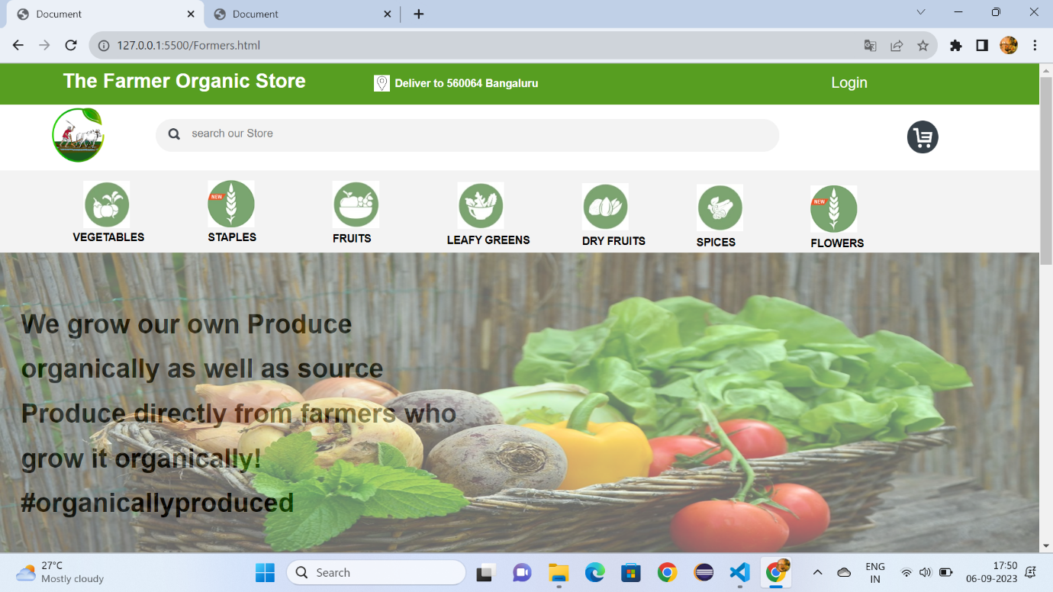

Fig:1.1

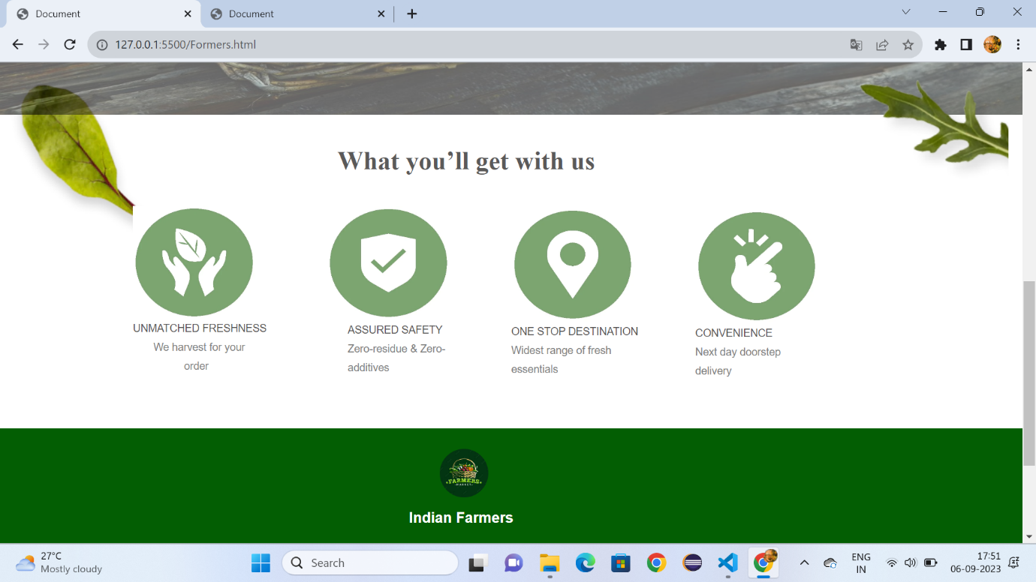 Fig:1.2

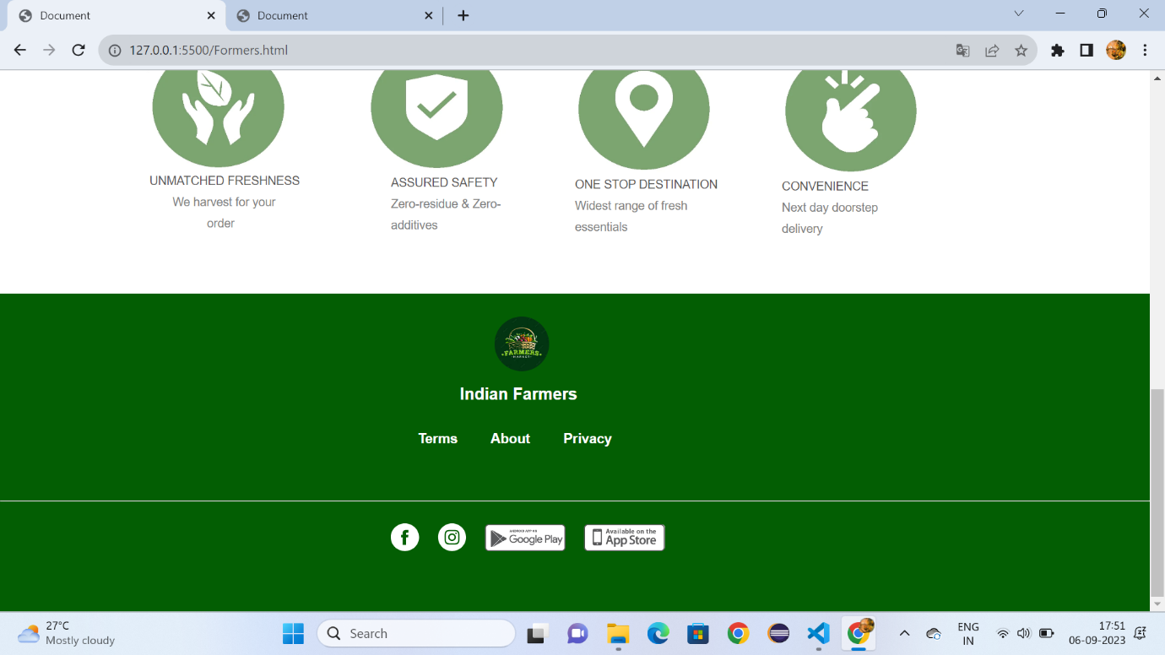

Fig:1.3

**Vegitables.html:-**

<!DOCTYPE html>

<html lang="en">

<head>

    <meta charset="UTF-8">

    <meta name="viewport" content="width=device-width, initial-scale=1.0">

    <title>Document</title>

    <link rel="stylesheet" href="vegetable.css">

    <style>

        *{

            margin: 0px;

            box-sizing: border-box;

        }

        .cp{

            font-size:small;

            font-family: sans-serif;

            color: gray;

            margin-left: 8%;

        }

        #a{

            height: 350px;

            background-color:rgb(3, 94, 3);

        }

        .v{

            color:white;

            text-decoration: none;

            font-size: 15px;

            font-family: sans-serif;

            margin-left: 30%;

            margin-top: 12%;

            position: absolute;

        }

    </style>

</head>

<body>

    <div id="id1">

        <h1 id="id2">The Farmer Organic Store</h1>

        <h1 id="id4">Deliver to 560064 Bangaluru</h1>

        <img id="id5" src="https://encrypted-tbn0.gstatic.com/images?q=tbn:ANd9GcSWcWFIwaZbvFXos5nhXronNlcxFZUTfopn0Q&usqp=CAU">

        <a id="id3" href="">Login</a>

     </div>

     <div id="d1">

     <a href="Formers.html"><img id="id6" src="https://i.pinimg.com/originals/36/69/ed/3669ed1bdbc3b511ecbb24ab1232dd2d.png"></a>

     <div id="d2">

         <img id="d4" src="https://gourmetgarden.in/cdn/shop/t/61/assets/header_search.svg?v=164721490308982976421646454342">

     <input id="d3" type="search" placeholder="search our Store">

     <img id="d5" src="https://encrypted-tbn0.gstatic.com/images?q=tbn:ANd9GcT05oMueo_F9aqt0U6I1fx1Lvp9IPstRwYd9_KXUnkVLQ&s">

     </div>

     </div>

     <div id="d6">

         <a class="class" href="vegitables.html" target="_self"><img class="c1" src="https://gourmetgarden.in/cdn/shop/files/5_4fab297e-c32f-4262-92b1-f56fb146a6c4-min.jpg?v=1637668254">

         <figcaption class="c2"><b>VEGETABLES</b></figcaption></a>

         <a class="class" href="sample.html" target="_self"><img class="c11" src="https://gourmetgarden.in/cdn/shop/files/Web_Icon-01_1_3ae0c896-c236-4a47-a3d6-03f260637e96.jpg?v=1667834188">

         <figcaption class="c22"><b>STAPLES</b></figcaption></a>

         <a class="class" href="Fruits.html" target="_self"><img class="c111" src="https://gourmetgarden.in/cdn/shop/files/2-compress-min.jpg?v=1637668281">

         <figcaption class="c222"><b>FRUITS</b></figcaption></a>

         <a class="class" href="Leafy.html"><img class="c111" style="margin-left: 44%;" src="https://gourmetgarden.in/cdn/shop/files/1-compress-min.jpg?v=1637668306">

         <figcaption class="c222" style="margin-left: 43%;"><b>LEAFY GREENS</b></figcaption></a>

         <a class="class" href="Dryfruits.html"><img class="c111" style="margin-left: 56%;margin-top: -7.1%;" src="https://gourmetgarden.in/cdn/shop/files/3-compress-min.jpg?v=1637668376">

         <figcaption class="c222" style="margin-left: 56%;margin-top: -1.1%;"><b>DRY FRUITS</b></figcaption></a>

         <a class="class" href="spices.html"><img class="c111" style="margin-left: 67%;margin-top: -7.1%;" src="https://gourmetgarden.in/cdn/shop/files/4-min.jpg?v=1637668400">

         <figcaption class="c222" style="margin-left: 67%;margin-top: -1.1%;"><b>SPICES</b></figcaption></a>

         <a class="class" href="flowers.html"><img class="c111" style="margin-left: 78%;margin-top: -7.1%;" src="https://gourmetgarden.in/cdn/shop/files/Web_Icon-01_1_3ae0c896-c236-4a47-a3d6-03f260637e96.jpg?v=1667834188">

         <figcaption class="c222" style="margin-left: 78%;margin-top: -1.1%;"><b>FLOWERS</b></figcaption></a>

     </div>

    <div style="height: 200px;background-color:#579e21;">

        <h1 style="font-family: sans-serif;font-size: xx-large;color: white;margin-left: 40%;padding-top:6%;">Fresh Vegetables</h1>

    </div>

    <div  style="width:80%;height:1500px;margin-left: 12%;">

        <div style="width: 20%;height: 300px;border: solid gray;margin-top: 10%;margin-left: 5%;">

        <img style="width: 80%;margin-top: 10%;margin-left: 5%;" src="https://gourmetgarden.in/cdn/shop/files/OTp_4_540x.jpg?v=1692690412">

        <img style="margin-left:-1%;margin-top: -10px;position: absolute;" src="https://cdn.shopify.com/s/files/1/0275/8020/3094/files/Star.svg?v=1633924464"><b style="margin-left:0.5%;margin-top: 4px;position: absolute;">15%<br>off</b>

        <h1 class="cp">onions & Tomato Bundle</h1>

        <br>

        <h1 class="cp"><strike>Rs.65</strike>&nbsp;<b style="color: black;">Rs.55</b></h1>

        <br>

        <h1 class="cp">500 gm each</h1>

        <br>

        <input style="border-radius: 50px;background-color:rgb(15, 211, 15);color: white;border: none;width: 60%;height: 30px;margin-left: 8%;" type="button" value="Add to Cart">

        </div>

        <div style="width: 20%;height: 300px;border: 2px solid gray;margin-left: 27%;margin-top: -300px;">

            <img style="width: 80%;margin-top: 10%;margin-left: 5%;" src="https://gourmetgarden.in/cdn/shop/products/CucumberBeitAlphs_600x600_5eb149e1-c864-4de5-8d71-cf9f83560e40_360x.jpg?v=1677238078">

            <img style="margin-left:-1%;margin-top: -10px;position: absolute;" src="https://cdn.shopify.com/s/files/1/0275/8020/3094/files/Star.svg?v=1633924464"><b style="margin-left:0.5%;margin-top: 4px;position: absolute;">15%<br>off</b>

            <h1 class="cp">Indian cucumber</h1>

            <br>

            <h1 class="cp"><strike>Rs.18</strike>&nbsp;<b style="color: black;">Rs.14</b></h1>

            <br>

            <h1 class="cp">450g-500g</h1>

            <br>

            <input style="border-radius: 50px;background-color:rgb(15, 211, 15);color: white;border: none;width: 60%;height: 30px;margin-left: 8%;" type="button" value="Add to Cart">

        </div>

        <div style="width: 20%;height: 300px;border: 2px solid grey;margin-left: 49%;margin-top: -300px;">

            <img style="width: 80%;margin-top: 10%;margin-left: 5%;height: 120px;" src="https://gourmetgarden.in/cdn/shop/products/fresh-cluster-beans-500x500_360x.jpg?v=1677053604">

            <img style="margin-left:-1%;margin-top: -10px;position: absolute;" src="https://cdn.shopify.com/s/files/1/0275/8020/3094/files/Star.svg?v=1633924464"><b style="margin-left:0.5%;margin-top: 4px;position: absolute;">15%<br>off</b>

            <h1 class="cp">Cluster Bean</h1>

            <br>

            <h1 class="cp"><strike>Rs.45</strike>&nbsp;<b style="color: black;">Rs.55</b></h1>

            <br>

            <h1 class="cp">500 gm</h1>

            <br>

            <input style="border-radius: 50px;background-color:rgb(15, 211, 15);color: white;border: none;width: 60%;height: 30px;margin-left: 8%;" type="button" value="Add to Cart">

        </div>

        <div style="width: 20%;height: 300px;border: 2px solid grey;margin-left: 71%;margin-top: -300px;">

            <img style="width: 80%;margin-top: 10%;margin-left: 5%;height: 120px;" src="https://gourmetgarden.in/cdn/shop/products/greenbr_360x.jpg?v=1665223697">

            <img style="margin-left:-1%;margin-top: -10px;position: absolute;" src="https://cdn.shopify.com/s/files/1/0275/8020/3094/files/Star.svg?v=1633924464"><b style="margin-left:0.5%;margin-top: 4px;position: absolute;">15%<br>off</b>

            <h1 class="cp">Brinjal Long</h1>

            <br>

            <h1 class="cp"><strike>Rs.45</strike>&nbsp;<b style="color: black;">Rs.55</b></h1>

            <br>

            <h1 class="cp">500 gm</h1>

            <br>

            <input style="border-radius: 50px;background-color:rgb(15, 211, 15);color: white;border: none;width: 60%;height: 30px;margin-left: 8%;" type="button" value="Add to Cart">

        </div>

        <div style="width: 20%;height: 300px;border: solid grey;margin-top: 5%;margin-left: 5%;">

            <img style="width: 80%;margin-top: 10%;margin-left: 5%;height: 120px;" src="https://gourmetgarden.in/cdn/shop/products/Bchilly_360x.jpg?v=1673761108">

            <img style="margin-left:-1%;margin-top: -10px;position: absolute;" src="https://cdn.shopify.com/s/files/1/0275/8020/3094/files/Star.svg?v=1633924464"><b style="margin-left:0.5%;margin-top: 4px;position: absolute;">15%<br>off</b>

            <h1 class="cp">Chilli Bajji</h1>

            <br>

            <h1 class="cp"><strike>Rs.37</strike>&nbsp;<b style="color: black;">Rs.25</b></h1>

            <br>

            <h1 class="cp">500 gm </h1>

            <br>

            <input style="border-radius: 50px;background-color:rgb(15, 211, 15);color: white;border: none;width: 60%;height: 30px;margin-left: 8%;" type="button" value="Add to Cart">

        </div>

        <div style="width: 20%;height: 300px;border: 2px solid grey;margin-left: 27%;margin-top: -300px;">

            <img style="width: 80%;margin-top: 10%;margin-left: 5%;height: 120px;" src="https://gourmetgarden.in/cdn/shop/products/31Cyz1HT8xL_360x.jpg?v=1668663416">

            <img style="margin-left:-1%;margin-top: -10px;position: absolute;" src="https://cdn.shopify.com/s/files/1/0275/8020/3094/files/Star.svg?v=1633924464"><b style="margin-left:0.5%;margin-top: 4px;position: absolute;">15%<br>off</b>

            <h1 class="cp">Brinjal Bharta</h1>

            <br>

            <h1 class="cp"><strike>Rs.57</strike>&nbsp;<b style="color: black;">Rs.45</b></h1>

            <br>

            <h1 class="cp">500 gm </h1>

            <br>

            <input style="border-radius: 50px;background-color:rgb(15, 211, 15);color: white;border: none;width: 60%;height: 30px;margin-left: 8%;" type="button" value="Add to Cart">

        </div>

        <div style="width: 20%;height: 300px;border: 2px solid grey;margin-left: 49%;margin-top: -300px;">

            <img style="width: 80%;margin-top: 10%;margin-left: 5%;height: 120px;" src="https://gourmetgarden.in/cdn/shop/products/hybird_360x.jpg?v=1666794548">

            <img style="margin-left:-1%;margin-top: -10px;position: absolute;" src="https://cdn.shopify.com/s/files/1/0275/8020/3094/files/Star.svg?v=1633924464"><b style="margin-left:0.5%;margin-top: 4px;position: absolute;">15%<br>off</b>

            <h1 class="cp"> Tomato-Hybrid</h1>

            <br>

            <h1 class="cp"><strike>Rs.28</strike>&nbsp;<b style="color: black;">Rs.22</b></h1>

            <br>

            <h1 class="cp">500 gm </h1>

            <br>

            <input style="border-radius: 50px;background-color:rgb(15, 211, 15);color: white;border: none;width: 60%;height: 30px;margin-left: 8%;" type="button" value="Add to Cart">

        </div>

        <div style="width: 20%;height: 300px;border: 2px solid grey;margin-left: 71%;margin-top: -300px;">

            <img style="width: 80%;margin-top: 10%;margin-left: 5%;height: 120px;" src="https://gourmetgarden.in/cdn/shop/products/springonion_360x.jpg?v=1630616591">

            <img style="margin-left:-1%;margin-top: -10px;position: absolute;" src="https://cdn.shopify.com/s/files/1/0275/8020/3094/files/Star.svg?v=1633924464"><b style="margin-left:0.5%;margin-top: 4px;position: absolute;">15%<br>off</b>

            <h1 class="cp"> Spring onions</h1>

            <br>

            <h1 class="cp"><strike>Rs.28</strike>&nbsp;<b style="color: black;">Rs.22</b></h1>

            <br>

            <h1 class="cp">500 gm </h1>

            <br>

            <input style="border-radius: 50px;background-color:rgb(15, 211, 15);color: white;border: none;width: 60%;height: 30px;margin-left: 8%;" type="button" value="Add to Cart">

        </div>

        <div style="width: 20%;height: 300px;border: solid grey;margin-top: 5%;margin-left: 5%;">

            <img style="width: 80%;margin-top: 10%;margin-left: 5%;" src="https://gourmetgarden.in/cdn/shop/products/Flatbeans_360x.jpg?v=1629991718">

            <img style="margin-left:-1%;margin-top: -10px;position: absolute;" src="https://cdn.shopify.com/s/files/1/0275/8020/3094/files/Star.svg?v=1633924464"><b style="margin-left:0.5%;margin-top: 4px;position: absolute;">15%<br>off</b>

            <h1 class="cp">Flat Beans</h1>

            <br>

            <h1 class="cp"><strike>Rs.65</strike>&nbsp;<b style="color: black;">Rs.55</b></h1>

            <br>

            <h1 class="cp">500 gm </h1>

            <br>

            <input style="border-radius: 50px;background-color:rgb(15, 211, 15);color: white;border: none;width: 60%;height: 30px;margin-left: 8%;" type="button" value="Add to Cart">

        </div>

        <div style="width: 20%;height: 300px;border: 2px solid grey;margin-left: 27%;margin-top: -300px;">

            <img style="width: 80%;margin-top: 10%;margin-left: 5%;" src="https://gourmetgarden.in/cdn/shop/products/potatobaby_360x.jpg?v=1652424896">

            <img style="margin-left:-1%;margin-top: -10px;position: absolute;" src="https://cdn.shopify.com/s/files/1/0275/8020/3094/files/Star.svg?v=1633924464"><b style="margin-left:0.5%;margin-top: 4px;position: absolute;">15%<br>off</b>

            <h1 class="cp">Baby Potato</h1>

            <br>

            <h1 class="cp"><strike>Rs.65</strike>&nbsp;<b style="color: black;">Rs.55</b></h1>

            <br>

            <h1 class="cp">500 gm </h1>

            <br>

            <input style="border-radius: 50px;background-color:rgb(15, 211, 15);color: white;border: none;width: 60%;height: 30px;margin-left: 8%;" type="button" value="Add to Cart">

        </div>

        <div style="width: 20%;height: 300px;border: 2px solid grey;margin-left: 49%;margin-top: -300px;">

            <img style="width: 80%;margin-top: 10%;margin-left: 5%;height: 120px;" src="https://gourmetgarden.in/cdn/shop/products/bittergourdbaby_b47ce1e7-3311-41c4-8d94-e99e74b7b5b9_360x.jpg?v=1657193955">

            <img style="margin-left:-1%;margin-top: -10px;position: absolute;" src="https://cdn.shopify.com/s/files/1/0275/8020/3094/files/Star.svg?v=1633924464"><b style="margin-left:0.5%;margin-top: 4px;position: absolute;">15%<br>off</b>

            <h1 class="cp">Baby Bitter gourd</h1>

            <br>

            <h1 class="cp"><strike>Rs.30</strike>&nbsp;<b style="color: black;">Rs.20</b></h1>

            <br>

            <h1 class="cp">500 gm </h1>

            <br>

            <input style="border-radius: 50px;background-color:rgb(15, 211, 15);color: white;border: none;width: 60%;height: 30px;margin-left: 8%;" type="button" value="Add to Cart">

        </div>

        <div style="width: 20%;height: 300px;border: 2px solid grey;margin-left: 71%;margin-top: -300px;">

            <img style="width: 80%;margin-top: 10%;margin-left: 5%;height: 120px;" src="https://gourmetgarden.in/cdn/shop/products/RidgeGourd_c5c8fcaa-f62b-4622-b3a1-b56b44ad80a5_360x.jpg?v=1652424851">

            <img style="margin-left:-1%;margin-top: -10px;position: absolute;" src="https://cdn.shopify.com/s/files/1/0275/8020/3094/files/Star.svg?v=1633924464"><b style="margin-left:0.5%;margin-top: 4px;position: absolute;">15%<br>off</b>

            <h1 class="cp">Ridge Gourd</h1>

            <br>

            <h1 class="cp"><strike>Rs.30</strike>&nbsp;<b style="color: black;">Rs.20</b></h1>

            <br>

            <h1 class="cp">500 gm </h1>

            <br>

            <input style="border-radius: 50px;background-color:rgb(15, 211, 15);color: white;border: none;width: 60%;height: 30px;margin-left: 8%;" type="button" value="Add to Cart">

        </div>

        <div style="width: 20%;height: 300px;border: solid grey;margin-top: 5%;margin-left: 5%;">

            <img style="width: 80%;margin-top: 10%;margin-left: 5%;" src="https://gourmetgarden.in/cdn/shop/products/Ivygourd_57dc0ecf-b0db-4854-b4b8-4f7c89099f20_360x.jpg?v=1629991188">

            <img style="margin-left:-1%;margin-top: -10px;position: absolute;" src="https://cdn.shopify.com/s/files/1/0275/8020/3094/files/Star.svg?v=1633924464"><b style="margin-left:0.5%;margin-top: 4px;position: absolute;">15%<br>off</b>

            <h1 class="cp">Ivy Gourd</h1>

            <br>

            <h1 class="cp"><strike>Rs.65</strike>&nbsp;<b style="color: black;">Rs.55</b></h1>

            <br>

            <h1 class="cp">500 gm </h1>

            <br>

            <input style="border-radius: 50px;background-color:rgb(15, 211, 15);color: white;border: none;width: 60%;height: 30px;margin-left: 8%;" type="button" value="Add to Cart">

        </div>

        <div style="width: 20%;height: 300px;border: 2px solid grey;margin-left: 27%;margin-top: -300px;">

            <img style="width: 80%;margin-top: 10%;margin-left: 5%;" src="https://gourmetgarden.in/cdn/shop/products/bananaraw_360x.jpg?v=1641748642">

            <img style="margin-left:-1%;margin-top: -10px;position: absolute;" src="https://cdn.shopify.com/s/files/1/0275/8020/3094/files/Star.svg?v=1633924464"><b style="margin-left:0.5%;margin-top: 4px;position: absolute;">15%<br>off</b>

            <h1 class="cp">Banana</h1>

            <br>

            <h1 class="cp"><strike>Rs.65</strike>&nbsp;<b style="color: black;">Rs.55</b></h1>

            <br>

            <h1 class="cp">500 gm </h1>

            <br>

            <input style="border-radius: 50px;background-color:rgb(15, 211, 15);color: white;border: none;width: 60%;height: 30px;margin-left: 8%;" type="button" value="Add to Cart"></div>

        <div style="width: 20%;height: 300px;border: 2px solid grey;margin-left: 49%;margin-top: -300px;">

            <img style="width: 80%;margin-top: 10%;margin-left: 5%;" src="https://gourmetgarden.in/cdn/shop/products/Eng-Cucumber_1_360x.png?v=1655983907">

            <img style="margin-left:-1%;margin-top: -10px;position: absolute;" src="https://cdn.shopify.com/s/files/1/0275/8020/3094/files/Star.svg?v=1633924464"><b style="margin-left:0.5%;margin-top: 4px;position: absolute;">15%<br>off</b>

            <h1 class="cp">English cucumber</h1>

            <br>

            <h1 class="cp"><strike>Rs.65</strike>&nbsp;<b style="color: black;">Rs.55</b></h1>

            <br>

            <h1 class="cp">500 gm </h1>

            <br>

            <input style="border-radius: 50px;background-color:rgb(15, 211, 15);color: white;border: none;width: 60%;height: 30px;margin-left: 8%;" type="button" value="Add to Cart">

        </div>

        <div style="width: 20%;height: 300px;border: 2px solid grey;margin-left: 71%;margin-top: -300px;">

            <img style="width: 80%;margin-top: 10%;margin-left: 5%;" src="https://gourmetgarden.in/cdn/shop/products/Ladies-Finger_360x.jpg?v=1655750440">

            <img style="margin-left:-1%;margin-top: -10px;position: absolute;" src="https://cdn.shopify.com/s/files/1/0275/8020/3094/files/Star.svg?v=1633924464"><b style="margin-left:0.5%;margin-top: 4px;position: absolute;">15%<br>off</b>

            <h1 class="cp">Ladies finger</h1>

            <br>

            <h1 class="cp"><strike>Rs.65</strike>&nbsp;<b style="color: black;">Rs.55</b></h1>

            <br>

            <h1 class="cp">500 gm </h1>

            <br>

            <input style="border-radius: 50px;background-color:rgb(15, 211, 15);color: white;border: none;width: 60%;height: 30px;margin-left: 8%;" type="button" value="Add to Cart">

        </div>

       </div>

       <div id="a">

        <img style="width: 60px;height: 60px;border-radius: 100px;position: absolute;margin-left: 43%;margin-top: 2%;" src="https://encrypted-tbn0.gstatic.com/images?q=tbn:ANd9GcQYYPsOYQ26sdslJ8sbWSKA6oskWX0R2W5bCg&usqp=CAU"><b style="font-family: sans-serif;font-size: large;margin-left: 40%;margin-top: 8%;position: absolute;color: white;">Indian Farmers</b>

        <a style="padding-left: 80px;" class="v" href=""><b>Terms</b></a>

        <a style="padding-left: 160px;" class="v" href=""><b>About</b></a>

        <a style="padding-left: 240px;" class="v" href=""><b>Privacy</b></a>

        <img style="padding-left: 34%;margin-top: 20%;" src="https://gourmetgarden.in/cdn/shop/t/61/assets/footer_fb_icon.svg?v=110095049522194708271646454327">&nbsp;&nbsp;&nbsp;&nbsp;

        <img src="https://gourmetgarden.in/cdn/shop/t/61/assets/footer_ig_icon.svg?v=110514061604159201831646454328">&nbsp;&nbsp;&nbsp;&nbsp;

        <img style="height: 30px;" src="https://cdn.shopify.com/s/files/1/0628/9725/8731/files/andoid-btn.png?v=1647696676">&nbsp;&nbsp;&nbsp;&nbsp;

        <img style="height: 30px;" src="https://cdn.shopify.com/s/files/1/0628/9725/8731/files/ios-btn.png?v=1647696676">

        <hr style="margin-top: -60px;">

    </div>

</body>

</html>

**Vegitables.css:-**

#id1{

    height: 50px;

    background-color:#579e21;

    border: none;

    width: 100%;

}

#id2{

    padding-top:0.6%;

    color: white;

    font-family: sans-serif;

    font-size: x-large;

    padding-left: 6%;

}

#id3{

    color:white;

    font-family: sans-serif;

   margin-top: -1.5%;

   position: absolute;

   text-decoration: none;

   font-size: large;

   margin-left: 80%;

}

#id4{

    color: white;

    margin-top: -2%;

    font-size: small;

    font-family: sans-serif;

    margin-left: 38%;

    margin-top: -1.5%;

}

#id5{

    width: 1.5%;

    height: 20px;

    margin-top: -10%;

    margin-left: 36%;

    margin-top: -1.4%;

    position: absolute;

}

#id6{

    width: 5%;

   height: 70px;

   margin-left: 5%;

   padding-top: 0.3%;

}

#d1{

    height: 80px;

}

#d2{

    border-radius: 50px;

    width: 60%;

    height: 40px;

    margin-top: -4.5%;

    margin-left: 15%;

    background-color: rgb(243, 243, 243);

}

#d3{

    outline: none;

    border: none;

    margin-left: 1%;

    background-color: rgb(243, 243, 243);

    padding-top: 0.8%;

    position: absolute;

}

#d4{

    margin-left: 2%;

    padding-top: 1.5%;

}

#d5{

    width: 3%;

    height: 40px;

    margin-left: 70%;

    position: absolute;

    margin-top: 2px;

}

#d6{

    height: 100px;

    background-color:rgb(243, 243, 243) ;

}

.c1{

    padding-top: 1%;

    width: 4.5%;

    height: 70px;

    margin-left: 8%;

}

.c2{

    font-family: sans-serif;

    font-size: small;

    margin-left: 7%;

}

.c11{

    padding-top: 1%;

    width: 4.5%;

    height: 70px;

    margin-left: 20%;

    margin-top: -7.1%;

    position: absolute;

}

.c22{

    font-family: sans-serif;

    font-size: small;

    margin-left: 20%;

    margin-top: -1.2%;

}

.c111{

    padding-top: 1%;

    width: 4.5%;

    height: 70px;

    margin-left: 32%;

    margin-top: -7.1%;

    position: absolute;

}

.c222{

    font-family: sans-serif;

    font-size: small;

    margin-left: 32%;

    margin-top: -1.1%;

}

.class{

    text-decoration: none;

    color: black;

    }

**Output :-**

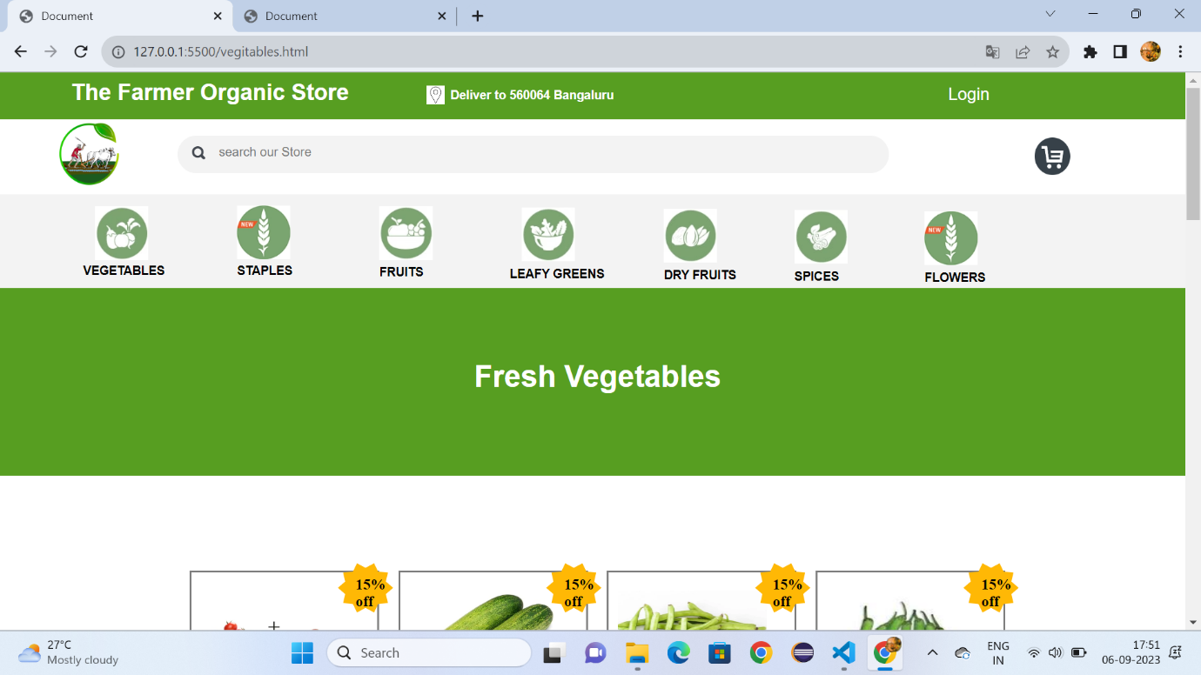

Fig:2.1

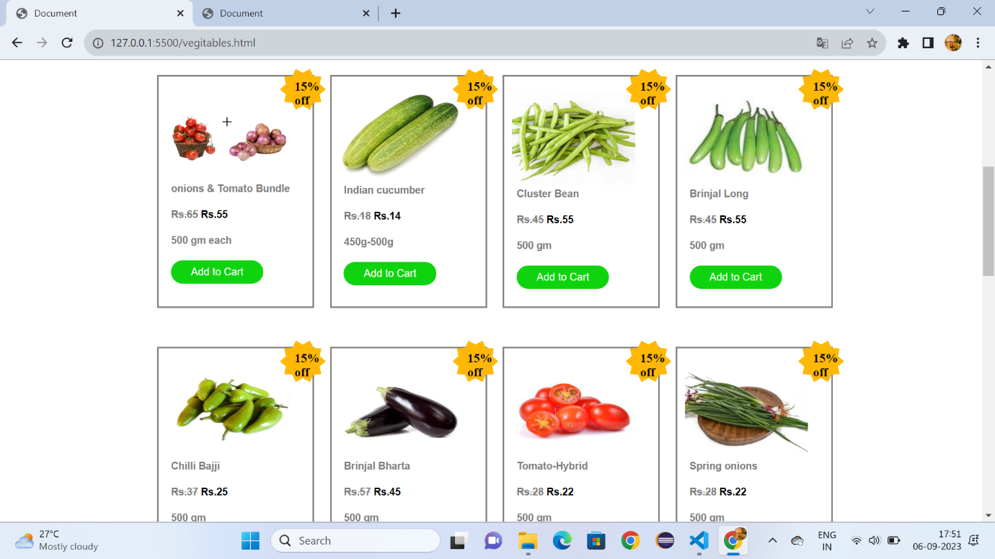

Fig:2.2

**Staples.html:**

<!DOCTYPE html>

<html lang="en">

<head>

    <meta charset="UTF-8">

    <meta name="viewport" content="width=device-width, initial-scale=1.0">

    <title>Document</title>

    <link rel="stylesheet" href="vegetable.css">

    <style>

        *{

            margin: 0px;

            box-sizing: border-box;

        }

        .cp{

            font-size:small;

            font-family: sans-serif;

            color: gray;

            margin-left: 8%;

        }

        #a{

            height: 350px;

            background-color:rgb(3, 94, 3);

        }

        .v{

            color:white;

            text-decoration: none;

            font-size: 15px;

            font-family: sans-serif;

            margin-left: 30%;

            margin-top: 12%;

            position: absolute;

        }

    </style>

</head>

<body>

    <div id="id1">

        <h1 id="id2">The Farmer Organic Store</h1>

        <h1 id="id4">Deliver to 560064 Bangaluru</h1>

        <img id="id5" src="https://encrypted-tbn0.gstatic.com/images?q=tbn:ANd9GcSWcWFIwaZbvFXos5nhXronNlcxFZUTfopn0Q&usqp=CAU">

        <a id="id3" href="">Login</a>

     </div>

     <div id="d1">

     <a href="Formers.html"><img id="id6" src="https://i.pinimg.com/originals/36/69/ed/3669ed1bdbc3b511ecbb24ab1232dd2d.png"></a>

     <div id="d2">

         <img id="d4" src="https://gourmetgarden.in/cdn/shop/t/61/assets/header_search.svg?v=164721490308982976421646454342">

     <input id="d3" type="search" placeholder="search our Store">

     <img id="d5" src="https://encrypted-tbn0.gstatic.com/images?q=tbn:ANd9GcT05oMueo_F9aqt0U6I1fx1Lvp9IPstRwYd9_KXUnkVLQ&s">

     </div>

     </div>

     <div id="d6">

         <a class="class" href="vegitables.html" target="_self"><img class="c1" src="https://gourmetgarden.in/cdn/shop/files/5_4fab297e-c32f-4262-92b1-f56fb146a6c4-min.jpg?v=1637668254">

         <figcaption class="c2"><b>VEGITABLES</b></figcaption></a>

         <a class="class" href="sample.html" target="_self"><img class="c11" src="https://gourmetgarden.in/cdn/shop/files/Web_Icon-01_1_3ae0c896-c236-4a47-a3d6-03f260637e96.jpg?v=1667834188">

         <figcaption class="c22"><b>SAMPLES</b></figcaption></a>

         <a class="class" href="Fruits.html" target="_self"><img class="c111" src="https://gourmetgarden.in/cdn/shop/files/2-compress-min.jpg?v=1637668281">

         <figcaption class="c222"><b>FRUITS</b></figcaption></a>

         <a class="class" href="Leafy.html"><img class="c111" style="margin-left: 44%;" src="https://gourmetgarden.in/cdn/shop/files/1-compress-min.jpg?v=1637668306">

         <figcaption class="c222" style="margin-left: 43%;"><b>LEAFY GREENS</b></figcaption></a>

         <a class="class" href="Dryfruits.html"><img class="c111" style="margin-left: 56%;margin-top: -7.1%;" src="https://gourmetgarden.in/cdn/shop/files/3-compress-min.jpg?v=1637668376">

         <figcaption class="c222" style="margin-left: 56%;margin-top: -1.1%;"><b>DRY FRUITS</b></figcaption></a>

         <a class="class" href="spices.html"><img class="c111" style="margin-left: 67%;margin-top: -7.1%;" src="https://gourmetgarden.in/cdn/shop/files/4-min.jpg?v=1637668400">

         <figcaption class="c222" style="margin-left: 67%;margin-top: -1.1%;"><b>SPICES</b></figcaption></a>

         <a class="class" href="flowers.html"><img class="c111" style="margin-left: 78%;margin-top: -7.1%;" src="https://gourmetgarden.in/cdn/shop/files/Web_Icon-01_1_3ae0c896-c236-4a47-a3d6-03f260637e96.jpg?v=1667834188">

         <figcaption class="c222" style="margin-left: 78%;margin-top: -1.1%;"><b>FLOWERS</b></figcaption></a>

     </div>

    <div style="height: 200px;background-color:#579e21;">

        <h1 style="font-family: sans-serif;font-size: xx-large;color: white;margin-left: 43%;padding-top:6%;">Staples</h1>

    </div>

    <div  style="width:80%;height:1200px;margin-left: 12%;">

        <div style="width: 20%;height: 300px;border: solid gray;margin-top: 10%;margin-left: 5%;">

        <img style="width: 80%;margin-top: 10%;margin-left: 5%;" src="https://gourmetgarden.in/cdn/shop/products/2_360x.jpg?v=1668960989">

        <img style="margin-left:-1%;margin-top: -10px;position: absolute;" src="https://cdn.shopify.com/s/files/1/0275/8020/3094/files/Star.svg?v=1633924464"><b style="margin-left:0.5%;margin-top: 4px;position: absolute;">13%<br>off</b>

        <h1 class="cp">Jaggery(Powder)</h1>

        <br>

        <h1 class="cp"><strike>Rs.101</strike>&nbsp;<b style="color: black;">Rs.88</b></h1>

        <br>

        <h1 class="cp">500 gm </h1>

        <br>

        <input style="border-radius: 50px;background-color:rgb(15, 211, 15);color: white;border: none;width: 60%;height: 30px;margin-left: 8%;" type="button" value="Add to Cart">

        </div>

        <div style="width: 20%;height: 300px;border: 2px solid gray;margin-left: 27%;margin-top: -300px;">

            <img style="width: 80%;margin-top: 10%;margin-left: 5%;" src="https://gourmetgarden.in/cdn/shop/products/ToorDaal_360x.jpg?v=1667618393">

            <img style="margin-left:-1%;margin-top: -10px;position: absolute;" src="https://cdn.shopify.com/s/files/1/0275/8020/3094/files/Star.svg?v=1633924464"><b style="margin-left:0.5%;margin-top: 4px;position: absolute;">13%<br>off</b>

            <h1 class="cp">Tool Dal</h1>

            <br>

            <h1 class="cp"><strike>Rs.167</strike>&nbsp;<b style="color: black;">Rs.145</b></h1>

            <br>

            <h1 class="cp">500g</h1>

            <br>

            <input style="border-radius: 50px;background-color:rgb(15, 211, 15);color: white;border: none;width: 60%;height: 30px;margin-left: 8%;" type="button" value="Add to Cart">

        </div>

        <div style="width: 20%;height: 300px;border: 2px solid grey;margin-left: 49%;margin-top: -300px;">

            <img style="width: 80%;margin-top: 10%;margin-left: 5%;height: 120px;" src="https://gourmetgarden.in/cdn/shop/products/moong_360x.jpg?v=1668961738">

            <img style="margin-left:-1%;margin-top: -10px;position: absolute;" src="https://cdn.shopify.com/s/files/1/0275/8020/3094/files/Star.svg?v=1633924464"><b style="margin-left:0.5%;margin-top: 4px;position: absolute;">13%<br>off</b>

            <h1 class="cp">Moong Dal</h1>

            <br>

            <h1 class="cp"><strike>Rs.45</strike>&nbsp;<b style="color: black;">Rs.55</b></h1>

            <br>

            <h1 class="cp">500 gm</h1>

            <br>

            <input style="border-radius: 50px;background-color:rgb(15, 211, 15);color: white;border: none;width: 60%;height: 30px;margin-left: 8%;" type="button" value="Add to Cart">

        </div>

        <div style="width: 20%;height: 300px;border: 2px solid grey;margin-left: 71%;margin-top: -300px;">

            <img style="width: 80%;margin-top: 10%;margin-left: 5%;height: 120px;" src="https://gourmetgarden.in/cdn/shop/products/Ragi_360x.jpg?v=1667905441">

            <img style="margin-left:-1%;margin-top: -10px;position: absolute;" src="https://cdn.shopify.com/s/files/1/0275/8020/3094/files/Star.svg?v=1633924464"><b style="margin-left:0.5%;margin-top: 4px;position: absolute;">13%<br>off</b>

            <h1 class="cp">Ragi Powder</h1>

            <br>

            <h1 class="cp"><strike>Rs.45</strike>&nbsp;<b style="color: black;">Rs.55</b></h1>

            <br>

            <h1 class="cp">500 gm</h1>

            <br>

            <input style="border-radius: 50px;background-color:rgb(15, 211, 15);color: white;border: none;width: 60%;height: 30px;margin-left: 8%;" type="button" value="Add to Cart">

        </div>

        <div style="width: 20%;height: 300px;border: solid grey;margin-top: 5%;margin-left: 5%;">

            <img style="width: 80%;margin-top: 10%;margin-left: 5%;height: 120px;" src="https://gourmetgarden.in/cdn/shop/products/urad_360x.jpg?v=1668961859">

            <img style="margin-left:-1%;margin-top: -10px;position: absolute;" src="https://cdn.shopify.com/s/files/1/0275/8020/3094/files/Star.svg?v=1633924464"><b style="margin-left:0.5%;margin-top: 4px;position: absolute;">13%<br>off</b>

            <h1 class="cp">Urad Dal(White | Split)</h1>

            <br>

            <h1 class="cp"><strike>Rs.37</strike>&nbsp;<b style="color: black;">Rs.25</b></h1>

            <br>

            <h1 class="cp">500 gm </h1>

            <br>

            <input style="border-radius: 50px;background-color:rgb(15, 211, 15);color: white;border: none;width: 60%;height: 30px;margin-left: 8%;" type="button" value="Add to Cart">

        </div>

        <div style="width: 20%;height: 300px;border: 2px solid grey;margin-left: 27%;margin-top: -300px;">

            <img style="width: 80%;margin-top: 10%;margin-left: 5%;height: 120px;" src="https://gourmetgarden.in/cdn/shop/products/BajraFlour_360x.jpg?v=1667617977">

            <img style="margin-left:-1%;margin-top: -10px;position: absolute;" src="https://cdn.shopify.com/s/files/1/0275/8020/3094/files/Star.svg?v=1633924464"><b style="margin-left:0.5%;margin-top: 4px;position: absolute;">13%<br>off</b>

            <h1 class="cp">Bajra Flour</h1>

            <br>

            <h1 class="cp"><strike>Rs.57</strike>&nbsp;<b style="color: black;">Rs.45</b></h1>

            <br>

            <h1 class="cp">500 gm </h1>

            <br>

            <input style="border-radius: 50px;background-color:rgb(15, 211, 15);color: white;border: none;width: 60%;height: 30px;margin-left: 8%;" type="button" value="Add to Cart">

        </div>

        <div style="width: 20%;height: 300px;border: 2px solid grey;margin-left: 49%;margin-top: -300px;">

            <img style="width: 80%;margin-top: 10%;margin-left: 5%;height: 120px;" src="https://gourmetgarden.in/cdn/shop/products/black_360x.jpg?v=1668961524">

            <img style="margin-left:-1%;margin-top: -10px;position: absolute;" src="https://cdn.shopify.com/s/files/1/0275/8020/3094/files/Star.svg?v=1633924464"><b style="margin-left:0.5%;margin-top: 4px;position: absolute;">13%<br>off</b>

            <h1 class="cp"> Black Rice</h1>

            <br>

            <h1 class="cp"><strike>Rs.70</strike>&nbsp;<b style="color: black;">Rs.50</b></h1>

            <br>

            <h1 class="cp">500 gm </h1>

            <br>

            <input style="border-radius: 50px;background-color:rgb(15, 211, 15);color: white;border: none;width: 60%;height: 30px;margin-left: 8%;" type="button" value="Add to Cart">

        </div>

        <div style="width: 20%;height: 300px;border: 2px solid grey;margin-left: 71%;margin-top: -300px;">

            <img style="width: 80%;margin-top: 10%;margin-left: 5%;height: 120px;" src="https://gourmetgarden.in/cdn/shop/products/kabuli_360x.jpg?v=1668961491">

            <img style="margin-left:-1%;margin-top: -10px;position: absolute;" src="https://cdn.shopify.com/s/files/1/0275/8020/3094/files/Star.svg?v=1633924464"><b style="margin-left:0.5%;margin-top: 4px;position: absolute;">13%<br>off</b>

            <h1 class="cp"> Kabuli channa</h1>

            <br>

            <h1 class="cp"><strike>Rs.28</strike>&nbsp;<b style="color: black;">Rs.22</b></h1>

            <br>

            <h1 class="cp">500 gm </h1>

            <br>

            <input style="border-radius: 50px;background-color:rgb(15, 211, 15);color: white;border: none;width: 60%;height: 30px;margin-left: 8%;" type="button" value="Add to Cart">

        </div>

        <div style="width: 20%;height: 300px;border: solid grey;margin-top: 5%;margin-left: 5%;">

            <img style="width: 80%;margin-top: 10%;margin-left: 5%;" src="https://gourmetgarden.in/cdn/shop/products/RedRice_360x.jpg?v=1667618323">

            <img style="margin-left:-1%;margin-top: -10px;position: absolute;" src="https://cdn.shopify.com/s/files/1/0275/8020/3094/files/Star.svg?v=1633924464"><b style="margin-left:0.5%;margin-top: 4px;position: absolute;">13%<br>off</b>

            <h1 class="cp">Red Rice</h1>

            <br>

            <h1 class="cp"><strike>Rs.65</strike>&nbsp;<b style="color: black;">Rs.55</b></h1>

            <br>

            <h1 class="cp">500 gm </h1>

            <br>

            <input style="border-radius: 50px;background-color:rgb(15, 211, 15);color: white;border: none;width: 60%;height: 30px;margin-left: 8%;" type="button" value="Add to Cart">

        </div>

        <div style="width: 20%;height: 300px;border: 2px solid grey;margin-left: 27%;margin-top: -300px;">

            <img style="width: 80%;margin-top: 10%;margin-left: 5%;" src="https://gourmetgarden.in/cdn/shop/products/redrajma_360x.jpg?v=1668963322">

            <img style="margin-left:-1%;margin-top: -10px;position: absolute;" src="https://cdn.shopify.com/s/files/1/0275/8020/3094/files/Star.svg?v=1633924464"><b style="margin-left:0.5%;margin-top: 4px;position: absolute;">13%<br>off</b>

            <h1 class="cp">Red Rajma</h1>

            <br>

            <h1 class="cp"><strike>Rs.65</strike>&nbsp;<b style="color: black;">Rs.55</b></h1>

            <br>

            <h1 class="cp">500 gm </h1>

            <br>

            <input style="border-radius: 50px;background-color:rgb(15, 211, 15);color: white;border: none;width: 60%;height: 30px;margin-left: 8%;" type="button" value="Add to Cart">

        </div>

        <div style="width: 20%;height: 300px;border: 2px solid grey;margin-left: 49%;margin-top: -300px;">

            <img style="width: 80%;margin-top: 10%;margin-left: 5%;height: 120px;" src="https://gourmetgarden.in/cdn/shop/products/3_91993d4d-ef64-4685-a8b1-5d0fe5125f7c_360x.jpg?v=1668961015">

            <img style="margin-left:-1%;margin-top: -10px;position: absolute;" src="https://cdn.shopify.com/s/files/1/0275/8020/3094/files/Star.svg?v=1633924464"><b style="margin-left:0.5%;margin-top: 4px;position: absolute;">13%<br>off</b>

            <h1 class="cp">Jaggery</h1>

            <br>

            <h1 class="cp"><strike>Rs.30</strike>&nbsp;<b style="color: black;">Rs.20</b></h1>

            <br>

            <h1 class="cp">500 gm </h1>

            <br>

            <input style="border-radius: 50px;background-color:rgb(15, 211, 15);color: white;border: none;width: 60%;height: 30px;margin-left: 8%;" type="button" value="Add to Cart">

        </div>

        <div style="width: 20%;height: 300px;border: 2px solid grey;margin-left: 71%;margin-top: -300px;">

            <img style="width: 80%;margin-top: 10%;margin-left: 5%;height: 120px;" src="https://gourmetgarden.in/cdn/shop/products/sona_360x.jpg?v=1668961899">

            <img style="margin-left:-1%;margin-top: -10px;position: absolute;" src="https://cdn.shopify.com/s/files/1/0275/8020/3094/files/Star.svg?v=1633924464"><b style="margin-left:0.5%;margin-top: 4px;position: absolute;">13%<br>off</b>

            <h1 class="cp">Sona Masoori Raw Rice</h1>

            <br>

            <h1 class="cp"><strike>Rs.30</strike>&nbsp;<b style="color: black;">Rs.20</b></h1>

            <br>

            <h1 class="cp">500 gm </h1>

            <br>

            <input style="border-radius: 50px;background-color:rgb(15, 211, 15);color: white;border: none;width: 60%;height: 30px;margin-left: 8%;" type="button" value="Add to Cart">

        </div>

       </div>

       <div id="a">

        <img style="width: 60px;height: 60px;border-radius: 100px;position: absolute;margin-left: 43%;margin-top: 2%;" src="https://encrypted-tbn0.gstatic.com/images?q=tbn:ANd9GcQYYPsOYQ26sdslJ8sbWSKA6oskWX0R2W5bCg&usqp=CAU"><b style="font-family: sans-serif;font-size: large;margin-left: 40%;margin-top: 8%;position: absolute;color: white;">Indian Farmers</b>

        <a style="padding-left: 80px;" class="v" href=""><b>Terms</b></a>

        <a style="padding-left: 160px;" class="v" href=""><b>About</b></a>

        <a style="padding-left: 240px;" class="v" href=""><b>Privacy</b></a>

        <img style="padding-left: 34%;margin-top: 20%;" src="https://gourmetgarden.in/cdn/shop/t/61/assets/footer_fb_icon.svg?v=110095049522194708271646454327">&nbsp;&nbsp;&nbsp;&nbsp;

        <img src="https://gourmetgarden.in/cdn/shop/t/61/assets/footer_ig_icon.svg?v=110514061604159201831646454328">&nbsp;&nbsp;&nbsp;&nbsp;

        <img style="height: 30px;" src="https://cdn.shopify.com/s/files/1/0628/9725/8731/files/andoid-btn.png?v=1647696676">&nbsp;&nbsp;&nbsp;&nbsp;

        <img style="height: 30px;" src="https://cdn.shopify.com/s/files/1/0628/9725/8731/files/ios-btn.png?v=1647696676">

        <hr style="margin-top: -60px;">

    </div>

</body>

</html>

**Staples.css:**

#id1{

    height: 50px;

    background-color:#579e21;

    border: none;

    width: 100%;

}

#id2{

    padding-top:0.6%;

    color: white;

    font-family: sans-serif;

    font-size: x-large;

    padding-left: 6%;

}

#id3{

    color:white;

    font-family: sans-serif;

   margin-top: -1.5%;

   position: absolute;

   text-decoration: none;

   font-size: large;

   margin-left: 80%;

}

#id4{

    color: white;

    margin-top: -2%;

    font-size: small;

    font-family: sans-serif;

    margin-left: 38%;

    margin-top: -1.5%;

}

#id5{

    width: 1.5%;

    height: 20px;

    margin-top: -10%;

    margin-left: 36%;

    margin-top: -1.4%;

    position: absolute;

}

#id6{

    width: 5%;

   height: 70px;

   margin-left: 5%;

   padding-top: 0.3%;

}

#d1{

    height: 80px;

}

#d2{

    border-radius: 50px;

    width: 60%;

    height: 40px;

    margin-top: -4.5%;

    margin-left: 15%;

    background-color: rgb(243, 243, 243);

}

#d3{

    outline: none;

    border: none;

    margin-left: 1%;

    background-color: rgb(243, 243, 243);

    padding-top: 0.8%;

    position: absolute;

}

#d4{

    margin-left: 2%;

    padding-top: 1.5%;

}

#d5{

    width: 3%;

    height: 40px;

    margin-left: 70%;

    position: absolute;

    margin-top: 2px;

}

#d6{

    height: 100px;

    background-color:rgb(243, 243, 243) ;

}

.c1{

    padding-top: 1%;

    width: 4.5%;

    height: 70px;

    margin-left: 8%;

}

.c2{

    font-family: sans-serif;

    font-size: small;

    margin-left: 7%;

}

.c11{

    padding-top: 1%;

    width: 4.5%;

    height: 70px;

    margin-left: 20%;

    margin-top: -7.1%;

    position: absolute;

}

.c22{

    font-family: sans-serif;

    font-size: small;

    margin-left: 20%;

    margin-top: -1.2%;

}

.c111{

    padding-top: 1%;

    width: 4.5%;

    height: 70px;

    margin-left: 32%;

    margin-top: -7.1%;

    position: absolute;

}

.c222{

    font-family: sans-serif;

    font-size: small;

    margin-left: 32%;

    margin-top: -1.1%;

}

.class{

    text-decoration: none;

    color: black;

    }

**Output:**

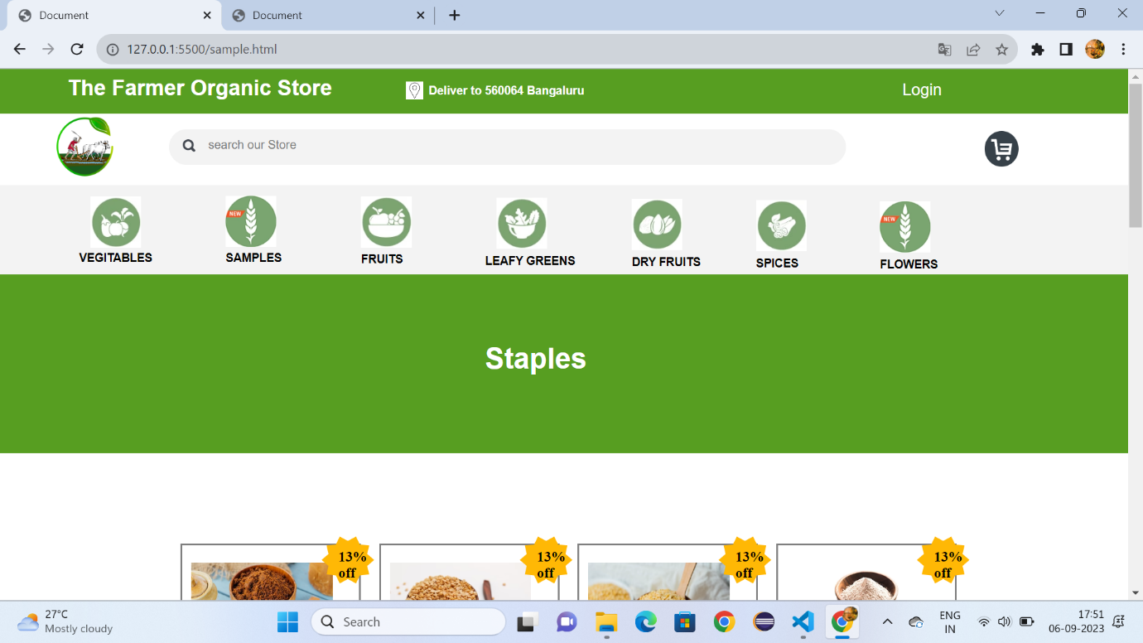

Fig:3.1

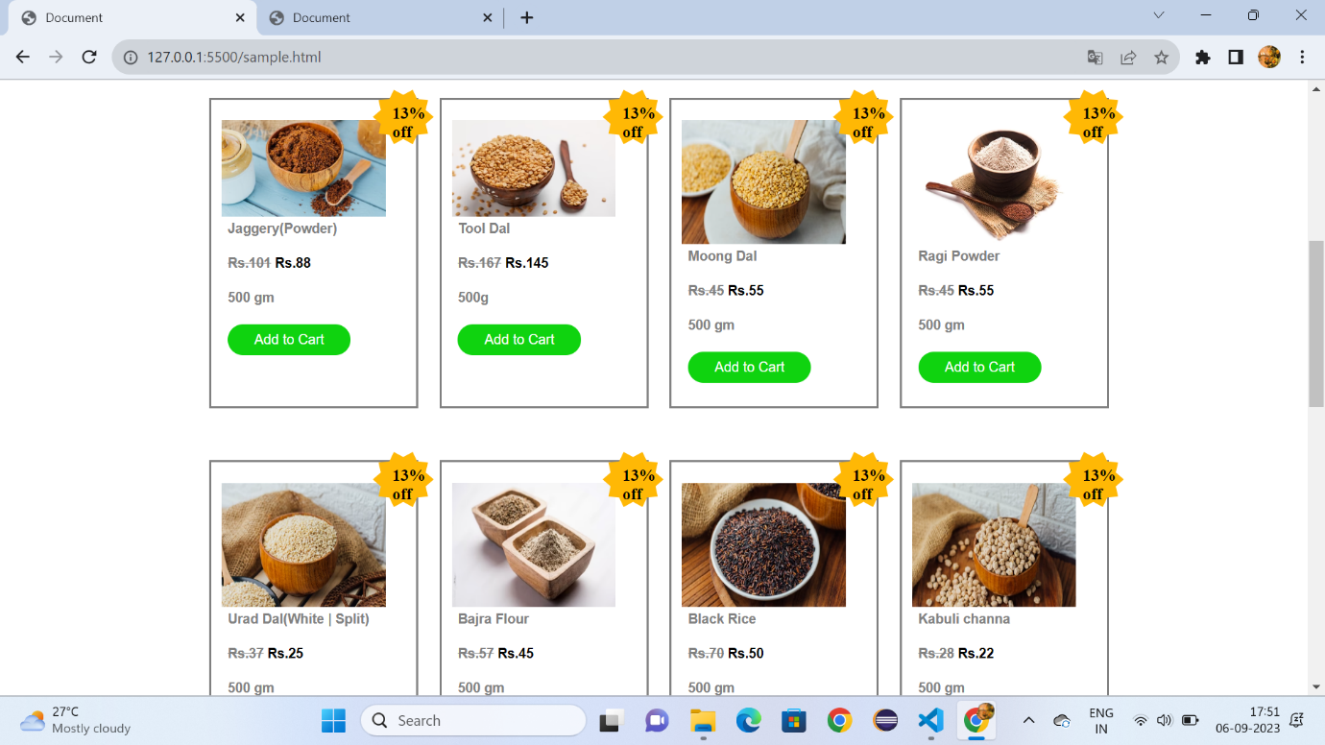

Fig:3.2

**Fruits.html:**

<!DOCTYPE html>

<html lang="en">

<head>

    <meta charset="UTF-8">

    <meta name="viewport" content="width=device-width, initial-scale=1.0">

    <title>Document</title>

    <link rel="stylesheet" href="vegetable.css">

    <style>

        *{

            margin: 0px;

            box-sizing: border-box;

        }

        .cp{

            font-size:small;

            font-family: sans-serif;

            color: gray;

            margin-left: 8%;

        }

        #a{

            height: 350px;

            background-color:rgb(3, 94, 3);

        }

        .v{

            color:white;

            text-decoration: none;

            font-size: 15px;

            font-family: sans-serif;

            margin-left: 30%;

            margin-top: 12%;

            position: absolute;

        }

    </style>

</head>

<body>

    <div id="id1">

        <h1 id="id2">The Farmer Organic Store</h1>

        <h1 id="id4">Deliver to 560064 Bangaluru</h1>

        <img id="id5" src="https://encrypted-tbn0.gstatic.com/images?q=tbn:ANd9GcSWcWFIwaZbvFXos5nhXronNlcxFZUTfopn0Q&usqp=CAU">

        <a id="id3" href="">Login</a>

     </div>

     <div id="d1">

     <a href="Formers.html"><img id="id6" src="https://i.pinimg.com/originals/36/69/ed/3669ed1bdbc3b511ecbb24ab1232dd2d.png"></a>

     <div id="d2">

         <img id="d4" src="https://gourmetgarden.in/cdn/shop/t/61/assets/header_search.svg?v=164721490308982976421646454342">

     <input id="d3" type="search" placeholder="search our Store">

     <img id="d5" src="https://encrypted-tbn0.gstatic.com/images?q=tbn:ANd9GcT05oMueo_F9aqt0U6I1fx1Lvp9IPstRwYd9_KXUnkVLQ&s">

     </div>

     </div>

     <div id="d6">

         <a class="class" href="vegitables.html" target="_self"><img class="c1" src="https://gourmetgarden.in/cdn/shop/files/5_4fab297e-c32f-4262-92b1-f56fb146a6c4-min.jpg?v=1637668254">

         <figcaption class="c2"><b>VEGITABLES</b></figcaption></a>

         <a class="class" href="sample.html" target="_self"><img class="c11" src="https://gourmetgarden.in/cdn/shop/files/Web_Icon-01_1_3ae0c896-c236-4a47-a3d6-03f260637e96.jpg?v=1667834188">

         <figcaption class="c22"><b>SAMPLES</b></figcaption></a>

         <a class="class" href="Fruits.html" target="_self"><img class="c111" src="https://gourmetgarden.in/cdn/shop/files/2-compress-min.jpg?v=1637668281">

         <figcaption class="c222"><b>FRUITS</b></figcaption></a>

         <a class="class" href="Leafy.html"><img class="c111" style="margin-left: 44%;" src="https://gourmetgarden.in/cdn/shop/files/1-compress-min.jpg?v=1637668306">

         <figcaption class="c222" style="margin-left: 43%;"><b>LEAFY GREENS</b></figcaption></a>

         <a class="class" href="Dryfruits.html"><img class="c111" style="margin-left: 56%;margin-top: -7.1%;" src="https://gourmetgarden.in/cdn/shop/files/3-compress-min.jpg?v=1637668376">

         <figcaption class="c222" style="margin-left: 56%;margin-top: -1.1%;"><b>DRY FRUITS</b></figcaption></a>

         <a class="class" href="spices.html"><img class="c111" style="margin-left: 67%;margin-top: -7.1%;" src="https://gourmetgarden.in/cdn/shop/files/4-min.jpg?v=1637668400">

         <figcaption class="c222" style="margin-left: 67%;margin-top: -1.1%;"><b>SPICES</b></figcaption></a>

         <a class="class" href="flowers.html"><img class="c111" style="margin-left: 78%;margin-top: -7.1%;" src="https://gourmetgarden.in/cdn/shop/files/Web_Icon-01_1_3ae0c896-c236-4a47-a3d6-03f260637e96.jpg?v=1667834188">

         <figcaption class="c222" style="margin-left: 78%;margin-top: -1.1%;"><b>FLOWERS</b></figcaption></a>

     </div>

    <div style="height: 200px;background-color:#579e21;">

        <h1 style="font-family: sans-serif;font-size: xx-large;color: white;margin-left: 45%;padding-top:6%;">Fruits</h1>

    </div>

    <div  style="width:80%;height:1200px;margin-left: 12%;">

        <div style="width: 20%;height: 300px;border: solid gray;margin-top: 10%;margin-left: 5%;">

        <img style="width: 80%;margin-top: 10%;margin-left: 5%;" src="https://gourmetgarden.in/cdn/shop/products/bananapachbale_5796b09b-5c41-4dc5-811d-8a664d8cf03c_360x.jpg?v=1652424878">

        <img style="margin-left:-1%;margin-top: -10px;position: absolute;" src="https://cdn.shopify.com/s/files/1/0275/8020/3094/files/Star.svg?v=1633924464"><b style="margin-left:0.5%;margin-top: 4px;position: absolute;">20%<br>off</b>

        <h1 class="cp">Banana</h1>

        <br>

        <h1 class="cp"><strike>Rs.101</strike>&nbsp;<b style="color: black;">Rs.88</b></h1>

        <br>

        <h1 class="cp">500 gm </h1>

        <br>

        <input style="border-radius: 50px;background-color:rgb(15, 211, 15);color: white;border: none;width: 60%;height: 30px;margin-left: 8%;" type="button" value="Add to Cart">

        </div>

        <div style="width: 20%;height: 300px;border: 2px solid gray;margin-left: 27%;margin-top: -300px;">

            <img style="width: 80%;margin-top: 10%;margin-left: 5%;" src="https://gourmetgarden.in/cdn/shop/products/Papaya_360x.png?v=1655699630">

            <img style="margin-left:-1%;margin-top: -10px;position: absolute;" src="https://cdn.shopify.com/s/files/1/0275/8020/3094/files/Star.svg?v=1633924464"><b style="margin-left:0.5%;margin-top: 4px;position: absolute;">20%<br>off</b>

            <h1 class="cp">Papaya</h1>

            <br>

            <h1 class="cp"><strike>Rs.167</strike>&nbsp;<b style="color: black;">Rs.145</b></h1>

            <br>

            <h1 class="cp">500g</h1>

            <br>

            <input style="border-radius: 50px;background-color:rgb(15, 211, 15);color: white;border: none;width: 60%;height: 30px;margin-left: 8%;" type="button" value="Add to Cart">

        </div>

        <div style="width: 20%;height: 300px;border: 2px solid grey;margin-left: 49%;margin-top: -300px;">

            <img style="width: 80%;margin-top: 10%;margin-left: 5%;height: 120px;" src="https://gourmetgarden.in/cdn/shop/products/Pomegranate_6f229b96-f19e-4799-b1fb-41e4dd08eb05_360x.jpg?v=1652424815">

            <img style="margin-left:-1%;margin-top: -10px;position: absolute;" src="https://cdn.shopify.com/s/files/1/0275/8020/3094/files/Star.svg?v=1633924464"><b style="margin-left:0.5%;margin-top: 4px;position: absolute;">20%<br>off</b>

            <h1 class="cp">Pomagranate</h1>

            <br>

            <h1 class="cp"><strike>Rs.45</strike>&nbsp;<b style="color: black;">Rs.55</b></h1>

            <br>

            <h1 class="cp">500 gm</h1>

            <br>

            <input style="border-radius: 50px;background-color:rgb(15, 211, 15);color: white;border: none;width: 60%;height: 30px;margin-left: 8%;" type="button" value="Add to Cart">

        </div>

        <div style="width: 20%;height: 300px;border: 2px solid grey;margin-left: 71%;margin-top: -300px;">

            <img style="width: 80%;margin-top: 10%;margin-left: 5%;height: 120px;" src="https://gourmetgarden.in/cdn/shop/products/orangemini_kumquat_360x.jpg?v=1630042187">

            <img style="margin-left:-1%;margin-top: -10px;position: absolute;" src="https://cdn.shopify.com/s/files/1/0275/8020/3094/files/Star.svg?v=1633924464"><b style="margin-left:0.5%;margin-top: 4px;position: absolute;">20%<br>off</b>

            <h1 class="cp">Mini Orenges</h1>

            <br>

            <h1 class="cp"><strike>Rs.45</strike>&nbsp;<b style="color: black;">Rs.55</b></h1>

            <br>

            <h1 class="cp">500 gm</h1>

            <br>

            <input style="border-radius: 50px;background-color:rgb(15, 211, 15);color: white;border: none;width: 60%;height: 30px;margin-left: 8%;" type="button" value="Add to Cart">

        </div>

        <div style="width: 20%;height: 300px;border: solid grey;margin-top: 5%;margin-left: 5%;">

            <img style="width: 80%;margin-top: 10%;margin-left: 5%;height: 120px;" src="https://gourmetgarden.in/cdn/shop/products/Pineapple_ac367bc2-bcfb-49dd-a68b-a404bafe5989_360x.jpg?v=1652424902">

            <img style="margin-left:-1%;margin-top: -10px;position: absolute;" src="https://cdn.shopify.com/s/files/1/0275/8020/3094/files/Star.svg?v=1633924464"><b style="margin-left:0.5%;margin-top: 4px;position: absolute;">20%<br>off</b>

            <h1 class="cp">Pinapple</h1>

            <br>

            <h1 class="cp"><strike>Rs.37</strike>&nbsp;<b style="color: black;">Rs.25</b></h1>

            <br>

            <h1 class="cp">500 gm </h1>

            <br>

            <input style="border-radius: 50px;background-color:rgb(15, 211, 15);color: white;border: none;width: 60%;height: 30px;margin-left: 8%;" type="button" value="Add to Cart">

        </div>

        <div style="width: 20%;height: 300px;border: 2px solid grey;margin-left: 27%;margin-top: -300px;">

            <img style="width: 80%;margin-top: 10%;margin-left: 5%;height: 120px;" src="https://gourmetgarden.in/cdn/shop/products/custardapple_360x.jpg?v=1630040864">

            <img style="margin-left:-1%;margin-top: -10px;position: absolute;" src="https://cdn.shopify.com/s/files/1/0275/8020/3094/files/Star.svg?v=1633924464"><b style="margin-left:0.5%;margin-top: 4px;position: absolute;">20%<br>off</b>

            <h1 class="cp">Custerd Apple</h1>

            <br>

            <h1 class="cp"><strike>Rs.57</strike>&nbsp;<b style="color: black;">Rs.45</b></h1>

            <br>

            <h1 class="cp">500 gm </h1>

            <br>

            <input style="border-radius: 50px;background-color:rgb(15, 211, 15);color: white;border: none;width: 60%;height: 30px;margin-left: 8%;" type="button" value="Add to Cart">

        </div>

        <div style="width: 20%;height: 300px;border: 2px solid grey;margin-left: 49%;margin-top: -300px;">

            <img style="width: 80%;margin-top: 10%;margin-left: 5%;height: 120px;" src="https://gourmetgarden.in/cdn/shop/products/redd_360x.jpg?v=1670306852">

            <img style="margin-left:-1%;margin-top: -10px;position: absolute;" src="https://cdn.shopify.com/s/files/1/0275/8020/3094/files/Star.svg?v=1633924464"><b style="margin-left:0.5%;margin-top: 4px;position: absolute;">20%<br>off</b>

            <h1 class="cp"> Apple</h1>

            <br>

            <h1 class="cp"><strike>Rs.70</strike>&nbsp;<b style="color: black;">Rs.50</b></h1>

            <br>

            <h1 class="cp">500 gm </h1>

            <br>

            <input style="border-radius: 50px;background-color:rgb(15, 211, 15);color: white;border: none;width: 60%;height: 30px;margin-left: 8%;" type="button" value="Add to Cart">

        </div>

        <div style="width: 20%;height: 300px;border: 2px solid grey;margin-left: 71%;margin-top: -300px;">

            <img style="width: 80%;margin-top: 10%;margin-left: 5%;height: 120px;" src="https://gourmetgarden.in/cdn/shop/products/GreenGrapes_grande_6a508e4b-1de2-440f-8cc6-1c56a20483b9_360x.jpg?v=1652789840">

            <img style="margin-left:-1%;margin-top: -10px;position: absolute;" src="https://cdn.shopify.com/s/files/1/0275/8020/3094/files/Star.svg?v=1633924464"><b style="margin-left:0.5%;margin-top: 4px;position: absolute;">20%<br>off</b>

            <h1 class="cp">Green Grapes</h1>

            <br>

            <h1 class="cp"><strike>Rs.28</strike>&nbsp;<b style="color: black;">Rs.22</b></h1>

            <br>

            <h1 class="cp">500 gm </h1>

            <br>

            <input style="border-radius: 50px;background-color:rgb(15, 211, 15);color: white;border: none;width: 60%;height: 30px;margin-left: 8%;" type="button" value="Add to Cart">

        </div>

        <div style="width: 20%;height: 300px;border: solid grey;margin-top: 5%;margin-left: 5%;">

            <img style="width: 80%;margin-top: 10%;margin-left: 5%;" src="https://gourmetgarden.in/cdn/shop/products/water-melon_360x.png?v=1655697764">

            <img style="margin-left:-1%;margin-top: -10px;position: absolute;" src="https://cdn.shopify.com/s/files/1/0275/8020/3094/files/Star.svg?v=1633924464"><b style="margin-left:0.5%;margin-top: 4px;position: absolute;">20%<br>off</b>

            <h1 class="cp">Water Melon</h1>

            <br>

            <h1 class="cp"><strike>Rs.65</strike>&nbsp;<b style="color: black;">Rs.55</b></h1>

            <br>

            <h1 class="cp">500 gm </h1>

            <br>

            <input style="border-radius: 50px;background-color:rgb(15, 211, 15);color: white;border: none;width: 60%;height: 30px;margin-left: 8%;" type="button" value="Add to Cart">

        </div>

        <div style="width: 20%;height: 300px;border: 2px solid grey;margin-left: 27%;margin-top: -300px;">

            <img style="width: 80%;margin-top: 10%;margin-left: 5%;height: 120px;" src="https://gourmetgarden.in/cdn/shop/products/image_360x.jpg?v=1606750765">

            <img style="margin-left:-1%;margin-top: -10px;position: absolute;" src="https://cdn.shopify.com/s/files/1/0275/8020/3094/files/Star.svg?v=1633924464"><b style="margin-left:0.5%;margin-top: 4px;position: absolute;">20%<br>off</b>

            <h1 class="cp">Thai Guava</h1>

            <br>

            <h1 class="cp"><strike>Rs.65</strike>&nbsp;<b style="color: black;">Rs.55</b></h1>

            <br>

            <h1 class="cp">500 gm </h1>

            <br>

            <input style="border-radius: 50px;background-color:rgb(15, 211, 15);color: white;border: none;width: 60%;height: 30px;margin-left: 8%;" type="button" value="Add to Cart">

        </div>

        <div style="width: 20%;height: 300px;border: 2px solid grey;margin-left: 49%;margin-top: -300px;">

            <img style="width: 80%;margin-top: 10%;margin-left: 5%;height: 120px;" src="https://gourmetgarden.in/cdn/shop/products/blueberries2_31645bd8-1ed8-42f3-942b-95f40c0b4a1f_360x.jpg?v=1652424829">

            <img style="margin-left:-1%;margin-top: -10px;position: absolute;" src="https://cdn.shopify.com/s/files/1/0275/8020/3094/files/Star.svg?v=1633924464"><b style="margin-left:0.5%;margin-top: 4px;position: absolute;">20%<br>off</b>

            <h1 class="cp">Blueberries</h1>

            <br>

            <h1 class="cp"><strike>Rs.30</strike>&nbsp;<b style="color: black;">Rs.20</b></h1>

            <br>

            <h1 class="cp">500 gm </h1>

            <br>

            <input style="border-radius: 50px;background-color:rgb(15, 211, 15);color: white;border: none;width: 60%;height: 30px;margin-left: 8%;" type="button" value="Add to Cart">

        </div>

        <div style="width: 20%;height: 300px;border: 2px solid grey;margin-left: 71%;margin-top: -300px;">

            <img style="width: 80%;margin-top: 10%;margin-left: 5%;height: 120px;" src="https://gourmetgarden.in/cdn/shop/products/Bangalorebluegrapes_9a4f5dc4-c11f-4bb7-802a-834bd86652c6_360x.jpg?v=1641748820">

            <img style="margin-left:-1%;margin-top: -10px;position: absolute;" src="https://cdn.shopify.com/s/files/1/0275/8020/3094/files/Star.svg?v=1633924464"><b style="margin-left:0.5%;margin-top: 4px;position: absolute;">20%<br>off</b>

            <h1 class="cp">Blue GrapesS</h1>

            <br>

            <h1 class="cp"><strike>Rs.30</strike>&nbsp;<b style="color: black;">Rs.20</b></h1>

            <br>

            <h1 class="cp">500 gm </h1>

            <br>

            <input style="border-radius: 50px;background-color:rgb(15, 211, 15);color: white;border: none;width: 60%;height: 30px;margin-left: 8%;" type="button" value="Add to Cart">

        </div>

       </div>

       <div id="a">

        <img style="width: 60px;height: 60px;border-radius: 100px;position: absolute;margin-left: 43%;margin-top: 2%;" src="https://encrypted-tbn0.gstatic.com/images?q=tbn:ANd9GcQYYPsOYQ26sdslJ8sbWSKA6oskWX0R2W5bCg&usqp=CAU"><b style="font-family: sans-serif;font-size: large;margin-left: 40%;margin-top: 8%;position: absolute;color: white;">Indian Farmers</b>

        <a style="padding-left: 80px;" class="v" href=""><b>Terms</b></a>

        <a style="padding-left: 160px;" class="v" href=""><b>About</b></a>

        <a style="padding-left: 240px;" class="v" href=""><b>Privacy</b></a>

        <img style="padding-left: 34%;margin-top: 20%;" src="https://gourmetgarden.in/cdn/shop/t/61/assets/footer_fb_icon.svg?v=110095049522194708271646454327">&nbsp;&nbsp;&nbsp;&nbsp;

        <img src="https://gourmetgarden.in/cdn/shop/t/61/assets/footer_ig_icon.svg?v=110514061604159201831646454328">&nbsp;&nbsp;&nbsp;&nbsp;

        <img style="height: 30px;" src="https://cdn.shopify.com/s/files/1/0628/9725/8731/files/andoid-btn.png?v=1647696676">&nbsp;&nbsp;&nbsp;&nbsp;

        <img style="height: 30px;" src="https://cdn.shopify.com/s/files/1/0628/9725/8731/files/ios-btn.png?v=1647696676">

        <hr style="margin-top: -60px;">

    </div>

</body>

</html>

**Fruits.css:**

#id1{

    height: 50px;

    background-color:#579e21;

    border: none;

    width: 100%;

}

#id2{

    padding-top:0.6%;

    color: white;

    font-family: sans-serif;

    font-size: x-large;

    padding-left: 6%;

}

#id3{

    color:white;

    font-family: sans-serif;

   margin-top: -1.5%;

   position: absolute;

   text-decoration: none;

   font-size: large;

   margin-left: 80%;

}

#id4{

    color: white;

    margin-top: -2%;

    font-size: small;

    font-family: sans-serif;

    margin-left: 38%;

    margin-top: -1.5%;

}

#id5{

    width: 1.5%;

    height: 20px;

    margin-top: -10%;

    margin-left: 36%;

    margin-top: -1.4%;

    position: absolute;

}

#id6{

    width: 5%;

   height: 70px;

   margin-left: 5%;

   padding-top: 0.3%;

}

#d1{

    height: 80px;

}

#d2{

    border-radius: 50px;

    width: 60%;

    height: 40px;

    margin-top: -4.5%;

    margin-left: 15%;

    background-color: rgb(243, 243, 243);

}

#d3{

    outline: none;

    border: none;

    margin-left: 1%;

    background-color: rgb(243, 243, 243);

    padding-top: 0.8%;

    position: absolute;

}

#d4{

    margin-left: 2%;

    padding-top: 1.5%;

}

#d5{

    width: 3%;

    height: 40px;

    margin-left: 70%;

    position: absolute;

    margin-top: 2px;

}

#d6{

    height: 100px;

    background-color:rgb(243, 243, 243) ;

}

.c1{

    padding-top: 1%;

    width: 4.5%;

    height: 70px;

    margin-left: 8%;

}

.c2{

    font-family: sans-serif;

    font-size: small;

    margin-left: 7%;

}

.c11{

    padding-top: 1%;

    width: 4.5%;

    height: 70px;

    margin-left: 20%;

    margin-top: -7.1%;

    position: absolute;

}

.c22{

    font-family: sans-serif;

    font-size: small;

    margin-left: 20%;

    margin-top: -1.2%;

}

.c111{

    padding-top: 1%;

    width: 4.5%;

    height: 70px;

    margin-left: 32%;

    margin-top: -7.1%;

    position: absolute;

}

.c222{

    font-family: sans-serif;

    font-size: small;

    margin-left: 32%;

    margin-top: -1.1%;

}

.class{

    text-decoration: none;

    color: black;

    }

**Output:**

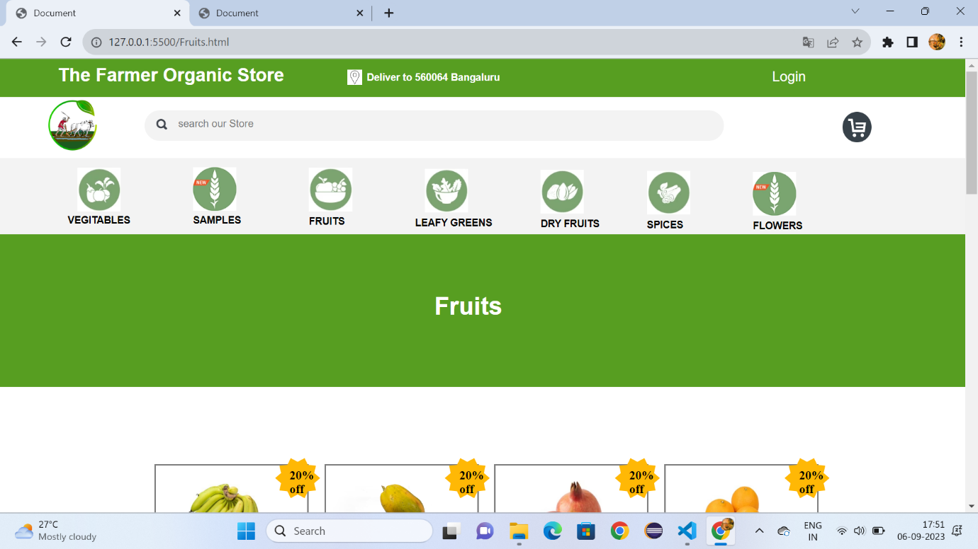

Fig:4.1

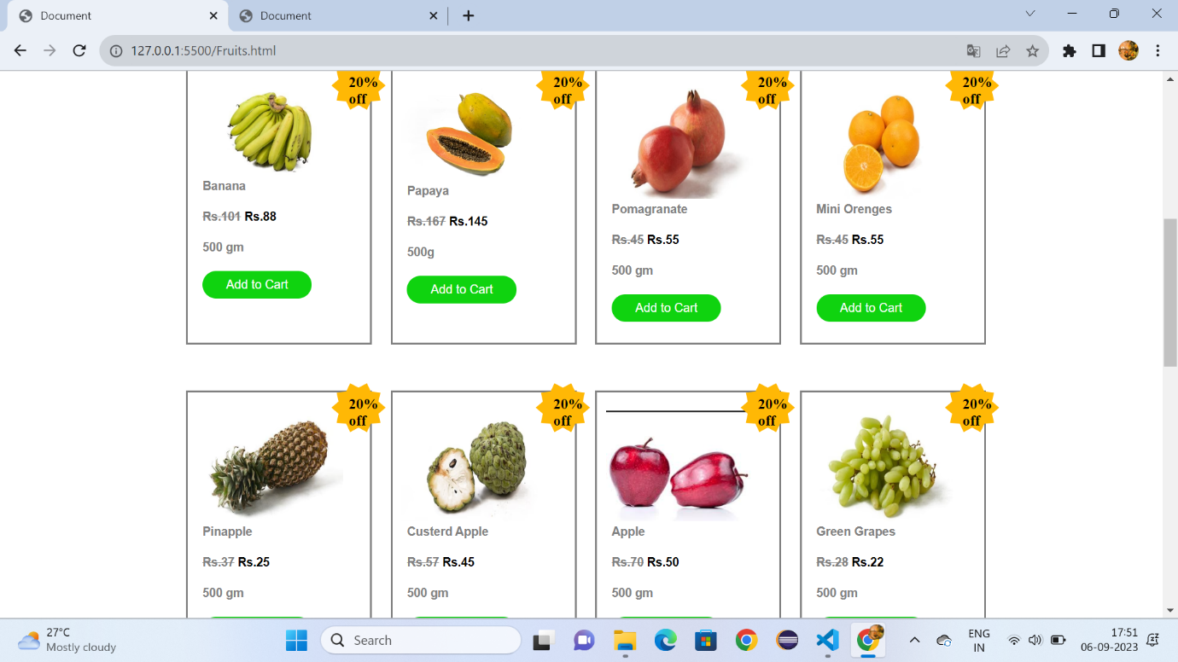

Fig:4.2

**Leafy Greens.html:**

<!DOCTYPE html>

<html lang="en">

<head>

    <meta charset="UTF-8">

    <meta name="viewport" content="width=device-width, initial-scale=1.0">

    <title>Document</title>

    <link rel="stylesheet" href="Leafy.css">

    <style>

        *{

            margin: 0px;

            box-sizing: border-box;

        }

        .cp{

            font-size:small;

            font-family: sans-serif;

            color: gray;

            margin-left: 8%;

        }

        #a{

            height: 350px;

            background-color:rgb(3, 94, 3);

        }

        .v{

            color:white;

            text-decoration: none;

            font-size: 15px;

            font-family: sans-serif;

            margin-left: 30%;

            margin-top: 12%;

            position: absolute;

        }

    </style>

</head>

<body>

    <div id="id1">

        <h1 id="id2">The Farmer Organic Store</h1>

        <h1 id="id4">Deliver to 560064 Bangaluru</h1>

        <img id="id5" src="https://encrypted-tbn0.gstatic.com/images?q=tbn:ANd9GcSWcWFIwaZbvFXos5nhXronNlcxFZUTfopn0Q&usqp=CAU">

        <a id="id3" href="">Login</a>

     </div>

     <div id="d1">

     <a href="Formers.html"><img id="id6" src="https://i.pinimg.com/originals/36/69/ed/3669ed1bdbc3b511ecbb24ab1232dd2d.png"></a>

     <div id="d2">

         <img id="d4" src="https://gourmetgarden.in/cdn/shop/t/61/assets/header_search.svg?v=164721490308982976421646454342">

     <input id="d3" type="search" placeholder="search our Store">

     <img id="d5" src="https://encrypted-tbn0.gstatic.com/images?q=tbn:ANd9GcT05oMueo_F9aqt0U6I1fx1Lvp9IPstRwYd9_KXUnkVLQ&s">

     </div>

     </div>

     <div id="d6">

         <a class="class" href="vegitables.html" target="_self"><img class="c1" src="https://gourmetgarden.in/cdn/shop/files/5_4fab297e-c32f-4262-92b1-f56fb146a6c4-min.jpg?v=1637668254">

         <figcaption class="c2"><b>VEGITABLES</b></figcaption></a>

         <a class="class" href="sample.html" target="_self"><img class="c11" src="https://gourmetgarden.in/cdn/shop/files/Web_Icon-01_1_3ae0c896-c236-4a47-a3d6-03f260637e96.jpg?v=1667834188">

         <figcaption class="c22"><b>SAMPLES</b></figcaption></a>

         <a class="class" href="Fruits.html" target="_self"><img class="c111" src="https://gourmetgarden.in/cdn/shop/files/2-compress-min.jpg?v=1637668281">

         <figcaption class="c222"><b>FRUITS</b></figcaption></a>

         <a class="class" href="Leafy.html" target="_self"><img class="c111" style="margin-left: 44%;" src="https://gourmetgarden.in/cdn/shop/files/1-compress-min.jpg?v=1637668306">

         <figcaption class="c222" style="margin-left: 43%;"><b>LEAFY GREENS</b></figcaption></a>

         <a class="class" href="Dryfruits.html"><img class="c111" style="margin-left: 56%;margin-top: -7.1%;" src="https://gourmetgarden.in/cdn/shop/files/3-compress-min.jpg?v=1637668376">

         <figcaption class="c222" style="margin-left: 56%;margin-top: -1.1%;"><b>DRY FRUITS</b></figcaption></a>

         <a class="class" href="spices.html"><img class="c111" style="margin-left: 67%;margin-top: -7.1%;" src="https://gourmetgarden.in/cdn/shop/files/4-min.jpg?v=1637668400">

         <figcaption class="c222" style="margin-left: 67%;margin-top: -1.1%;"><b>SPICES</b></figcaption></a>

         <a class="class" href="flowers.html"><img class="c111" style="margin-left: 78%;margin-top: -7.1%;" src="https://gourmetgarden.in/cdn/shop/files/Web_Icon-01_1_3ae0c896-c236-4a47-a3d6-03f260637e96.jpg?v=1667834188">

         <figcaption class="c222" style="margin-left: 78%;margin-top: -1.1%;"><b>FLOWERS</b></figcaption></a>

     </div>

    <div style="height: 200px;background-color:#579e21;">

        <h1 style="font-family: sans-serif;font-size: xx-large;color: white;margin-left: 41%;padding-top:6%;">Leafy Greens</h1>

    </div>

    <div  style="width:80%;height:1200px;margin-left: 12%;">

        <div style="width: 20%;height: 300px;border: solid gray;margin-top: 10%;margin-left: 5%;">

        <img style="width: 80%;margin-top: 10%;margin-left: 5%;" src="https://gourmetgarden.in/cdn/shop/products/Palak-Root-cut_360x.jpg?v=1660816427">

        <img style="margin-left:-1%;margin-top: -10px;position: absolute;" src="https://cdn.shopify.com/s/files/1/0275/8020/3094/files/Star.svg?v=1633924464"><b style="margin-left:0.5%;margin-top: 4px;position: absolute;">22%<br>off</b>

        <h1 class="cp">Palak (Root-cut)</h1>

        <br>

        <h1 class="cp"><strike>Rs.37</strike>&nbsp;<b style="color: black;">Rs.29</b></h1>

        <br>

        <h1 class="cp">500 gm </h1>

        <br>

        <input style="border-radius: 50px;background-color:rgb(15, 211, 15);color: white;border: none;width: 60%;height: 30px;margin-left: 8%;" type="button" value="Add to Cart">

        </div>

        <div style="width: 20%;height: 300px;border: 2px solid gray;margin-left: 27%;margin-top: -300px;">

            <img style="width: 80%;margin-top: 10%;margin-left: 5%;" src="https://gourmetgarden.in/cdn/shop/products/curryleaves_757f49e1-ff15-4785-8119-533e6826f118_360x.jpg?v=1652424849">

            <img style="margin-left:-1%;margin-top: -10px;position: absolute;" src="https://cdn.shopify.com/s/files/1/0275/8020/3094/files/Star.svg?v=1633924464"><b style="margin-left:0.5%;margin-top: 4px;position: absolute;">22%<br>off</b>

            <h1 class="cp">Curry Leaves</h1>

            <br>

            <h1 class="cp"><strike>Rs.19</strike>&nbsp;<b style="color: black;">Rs.15</b></h1>

            <br>

            <h1 class="cp">100g</h1>

            <br>

            <input style="border-radius: 50px;background-color:rgb(15, 211, 15);color: white;border: none;width: 60%;height: 30px;margin-left: 8%;" type="button" value="Add to Cart">

        </div>

        <div style="width: 20%;height: 300px;border: 2px solid grey;margin-left: 49%;margin-top: -300px;">

            <img style="width: 80%;margin-top: 10%;margin-left: 5%;height: 120px;" src="https://gourmetgarden.in/cdn/shop/products/mint_360x.jpg?v=1652424875">

            <img style="margin-left:-1%;margin-top: -10px;position: absolute;" src="https://cdn.shopify.com/s/files/1/0275/8020/3094/files/Star.svg?v=1633924464"><b style="margin-left:0.5%;margin-top: 4px;position: absolute;">22%<br>off</b>

            <h1 class="cp">Mint (Root-cut)</h1>

            <br>

            <h1 class="cp"><strike>Rs.23</strike>&nbsp;<b style="color: black;">Rs.18</b></h1>

            <br>

            <h1 class="cp">100 gm</h1>

            <br>

            <input style="border-radius: 50px;background-color:rgb(15, 211, 15);color: white;border: none;width: 60%;height: 30px;margin-left: 8%;" type="button" value="Add to Cart">

        </div>

        <div style="width: 20%;height: 300px;border: 2px solid grey;margin-left: 71%;margin-top: -300px;">

            <img style="width: 80%;margin-top: 10%;margin-left: 5%;height: 120px;" src="https://gourmetgarden.in/cdn/shop/products/methi_360x.jpg?v=1652424862">

            <img style="margin-left:-1%;margin-top: -10px;position: absolute;" src="https://cdn.shopify.com/s/files/1/0275/8020/3094/files/Star.svg?v=1633924464"><b style="margin-left:0.5%;margin-top: 4px;position: absolute;">22%<br>off</b>

            <h1 class="cp">Methi (Root-cut)</h1>

            <br>

            <h1 class="cp"><strike>Rs.45</strike>&nbsp;<b style="color: black;">Rs.55</b></h1>

            <br>

            <h1 class="cp">100 gm</h1>

            <br>

            <input style="border-radius: 50px;background-color:rgb(15, 211, 15);color: white;border: none;width: 60%;height: 30px;margin-left: 8%;" type="button" value="Add to Cart">

        </div>

        <div style="width: 20%;height: 300px;border: solid grey;margin-top: 5%;margin-left: 5%;">

            <img style="width: 80%;margin-top: 10%;margin-left: 5%;height: 120px;" src="https://gourmetgarden.in/cdn/shop/products/Coriender-root-cut_360x.jpg?v=1660814636">

            <img style="margin-left:-1%;margin-top: -10px;position: absolute;" src="https://cdn.shopify.com/s/files/1/0275/8020/3094/files/Star.svg?v=1633924464"><b style="margin-left:0.5%;margin-top: 4px;position: absolute;">13%<br>off</b>

            <h1 class="cp">Coriander (Root -cut)</h1>

            <br>

            <h1 class="cp"><strike>Rs.37</strike>&nbsp;<b style="color: black;">Rs.25</b></h1>

            <br>

            <h1 class="cp">100 gm </h1>

            <br>

            <input style="border-radius: 50px;background-color:rgb(15, 211, 15);color: white;border: none;width: 60%;height: 30px;margin-left: 8%;" type="button" value="Add to Cart">

        </div>

        <div style="width: 20%;height: 300px;border: 2px solid grey;margin-left: 27%;margin-top: -300px;">

            <img style="width: 80%;margin-top: 10%;margin-left: 5%;height: 120px;" src="https://gourmetgarden.in/cdn/shop/products/Coriender-root-cut_360x.jpg?v=1660814636">

            <img style="margin-left:-1%;margin-top: -10px;position: absolute;" src="https://cdn.shopify.com/s/files/1/0275/8020/3094/files/Star.svg?v=1633924464"><b style="margin-left:0.5%;margin-top: 4px;position: absolute;">13%<br>off</b>

            <h1 class="cp">Italian Basil</h1>

            <br>

            <h1 class="cp"><strike>Rs.25</strike>&nbsp;<b style="color: black;">Rs.20</b></h1>

            <br>

            <h1 class="cp">100 gm </h1>

            <br>

            <input style="border-radius: 50px;background-color:rgb(15, 211, 15);color: white;border: none;width: 60%;height: 30px;margin-left: 8%;" type="button" value="Add to Cart">

        </div>

        <div style="width: 20%;height: 300px;border: 2px solid grey;margin-left: 49%;margin-top: -300px;">

            <img style="width: 80%;margin-top: 10%;margin-left: 5%;height: 120px;" src="https://gourmetgarden.in/cdn/shop/products/thyme_e36961a9-4e89-4753-bc0c-53228595cb9e_360x.jpg?v=1630062469">

            <img style="margin-left:-1%;margin-top: -10px;position: absolute;" src="https://cdn.shopify.com/s/files/1/0275/8020/3094/files/Star.svg?v=1633924464"><b style="margin-left:0.5%;margin-top: 4px;position: absolute;">13%<br>off</b>

            <h1 class="cp"> Thyme</h1>

            <br>

            <h1 class="cp"><strike>Rs.14</strike>&nbsp;<b style="color: black;">Rs.11</b></h1>

            <br>

            <h1 class="cp">25 gm </h1>

            <br>

            <input style="border-radius: 50px;background-color:rgb(15, 211, 15);color: white;border: none;width: 60%;height: 30px;margin-left: 8%;" type="button" value="Add to Cart">

        </div>

        <div style="width: 20%;height: 300px;border: 2px solid grey;margin-left: 71%;margin-top: -300px;">

            <img style="width: 80%;margin-top: 10%;margin-left: 5%;height: 120px;" src="https://gourmetgarden.in/cdn/shop/products/Dill-Leaves_360x.jpg?v=1655788059">

            <img style="margin-left:-1%;margin-top: -10px;position: absolute;" src="https://cdn.shopify.com/s/files/1/0275/8020/3094/files/Star.svg?v=1633924464"><b style="margin-left:0.5%;margin-top: 4px;position: absolute;">13%<br>off</b>

            <h1 class="cp"> Kabuli channa</h1>

            <br>

            <h1 class="cp"><strike>Rs.28</strike>&nbsp;<b style="color: black;">Rs.22</b></h1>

            <br>

            <h1 class="cp">500 gm </h1>

            <br>

            <input style="border-radius: 50px;background-color:rgb(15, 211, 15);color: white;border: none;width: 60%;height: 30px;margin-left: 8%;" type="button" value="Add to Cart">

        </div>

        <div style="width: 20%;height: 300px;border: solid grey;margin-top: 5%;margin-left: 5%;">

            <img style="width: 80%;margin-top: 10%;margin-left: 5%;" src="https://gourmetgarden.in/cdn/shop/products/Rosner-Lettuce_360x.jpg?v=1632915223">

            <img style="margin-left:-1%;margin-top: -10px;position: absolute;" src="https://cdn.shopify.com/s/files/1/0275/8020/3094/files/Star.svg?v=1633924464"><b style="margin-left:0.5%;margin-top: 4px;position: absolute;">13%<br>off</b>

            <h1 class="cp">Iceberg Lettuce</h1>

            <br>

            <h1 class="cp"><strike>Rs.65</strike>&nbsp;<b style="color: black;">Rs.55</b></h1>

            <br>

            <h1 class="cp">500 gm </h1>

            <br>

            <input style="border-radius: 50px;background-color:rgb(15, 211, 15);color: white;border: none;width: 60%;height: 30px;margin-left: 8%;" type="button" value="Add to Cart">

        </div>

        <div style="width: 20%;height: 300px;border: 2px solid grey;margin-left: 27%;margin-top: -300px;">

            <img style="width: 80%;margin-top: 10%;margin-left: 5%;" src="https://gourmetgarden.in/cdn/shop/products/rocket_360x.jpg?v=1630616548">

            <img style="margin-left:-1%;margin-top: -10px;position: absolute;" src="https://cdn.shopify.com/s/files/1/0275/8020/3094/files/Star.svg?v=1633924464"><b style="margin-left:0.5%;margin-top: 4px;position: absolute;">13%<br>off</b>

            <h1 class="cp">Rocket (Arugular)</h1>

            <br>

            <h1 class="cp"><strike>Rs.37</strike>&nbsp;<b style="color: black;">Rs.29</b></h1>

            <br>

            <h1 class="cp">500 gm </h1>

            <br>

            <input style="border-radius: 50px;background-color:rgb(15, 211, 15);color: white;border: none;width: 60%;height: 30px;margin-left: 8%;" type="button" value="Add to Cart">

        </div>

        <div style="width: 20%;height: 300px;border: 2px solid grey;margin-left: 49%;margin-top: -300px;">

            <img style="width: 80%;margin-top: 10%;margin-left: 5%;height: 120px;" src="https://gourmetgarden.in/cdn/shop/products/bokchoy_aa49e962-6b86-4cee-9963-c9709293ca87_360x.jpg?v=1630062119">

            <img style="margin-left:-1%;margin-top: -10px;position: absolute;" src="https://cdn.shopify.com/s/files/1/0275/8020/3094/files/Star.svg?v=1633924464"><b style="margin-left:0.5%;margin-top: 4px;position: absolute;">13%<br>off</b>

            <h1 class="cp">Bok Choy</h1>

            <br>

            <h1 class="cp"><strike>Rs.30</strike>&nbsp;<b style="color: black;">Rs.20</b></h1>

            <br>

            <h1 class="cp">150 gm </h1>

            <br>

            <input style="border-radius: 50px;background-color:rgb(15, 211, 15);color: white;border: none;width: 60%;height: 30px;margin-left: 8%;" type="button" value="Add to Cart">

        </div>

        <div style="width: 20%;height: 300px;border: 2px solid grey;margin-left: 71%;margin-top: -300px;">

            <img style="width: 80%;margin-top: 10%;margin-left: 5%;height: 120px;" src="https://gourmetgarden.in/cdn/shop/products/microgreensgongura_3c8266e9-74ec-4c34-9874-30c24ca548f0_360x.jpg?v=1630064775">

            <img style="margin-left:-1%;margin-top: -10px;position: absolute;" src="https://cdn.shopify.com/s/files/1/0275/8020/3094/files/Star.svg?v=1633924464"><b style="margin-left:0.5%;margin-top: 4px;position: absolute;">13%<br>off</b>

            <h1 class="cp">Gongura Microgreens</h1>

            <br>

            <h1 class="cp"><b style="color: black;">Rs.20</b></h1>

            <br>

            <h1 class="cp">500 gm </h1>

            <br>

            <input style="border-radius: 50px;background-color:rgb(15, 211, 15);color: white;border: none;width: 60%;height: 30px;margin-left: 8%;" type="button" value="Add to Cart">

        </div>

       </div>

       <div id="a">

        <img style="width: 60px;height: 60px;border-radius: 100px;position: absolute;margin-left: 43%;margin-top: 2%;" src="https://encrypted-tbn0.gstatic.com/images?q=tbn:ANd9GcQYYPsOYQ26sdslJ8sbWSKA6oskWX0R2W5bCg&usqp=CAU"><b style="font-family: sans-serif;font-size: large;margin-left: 40%;margin-top: 8%;position: absolute;color: white;">Indian Farmers</b>

        <a style="padding-left: 80px;" class="v" href=""><b>Terms</b></a>

        <a style="padding-left: 160px;" class="v" href=""><b>About</b></a>

        <a style="padding-left: 240px;" class="v" href=""><b>Privacy</b></a>

        <img style="padding-left: 34%;margin-top: 20%;" src="https://gourmetgarden.in/cdn/shop/t/61/assets/footer_fb_icon.svg?v=110095049522194708271646454327">&nbsp;&nbsp;&nbsp;&nbsp;

        <img src="https://gourmetgarden.in/cdn/shop/t/61/assets/footer_ig_icon.svg?v=110514061604159201831646454328">&nbsp;&nbsp;&nbsp;&nbsp;

        <img style="height: 30px;" src="https://cdn.shopify.com/s/files/1/0628/9725/8731/files/andoid-btn.png?v=1647696676">&nbsp;&nbsp;&nbsp;&nbsp;

        <img style="height: 30px;" src="https://cdn.shopify.com/s/files/1/0628/9725/8731/files/ios-btn.png?v=1647696676">

        <hr style="margin-top: -60px;">

    </div>

</body>

</html>

**Leafy Greens.CSS:**

#id1{

    height: 50px;

    background-color:#579e21;

    border: none;

    width: 100%;

}

#id2{

    padding-top:0.6%;

    color: white;

    font-family: sans-serif;

    font-size: x-large;

    padding-left: 6%;

}

#id3{

    color:white;

    font-family: sans-serif;

   margin-top: -1.5%;

   position: absolute;

   text-decoration: none;

   font-size: large;

   margin-left: 80%;

}

#id4{

    color: white;

    margin-top: -2%;

    font-size: small;

    font-family: sans-serif;

    margin-left: 38%;

    margin-top: -1.5%;

}

#id5{

    width: 1.5%;

    height: 20px;

    margin-top: -10%;

    margin-left: 36%;

    margin-top: -1.4%;

    position: absolute;

}

#id6{

    width: 5%;

   height: 70px;

   margin-left: 5%;

   padding-top: 0.3%;

}

#d1{

    height: 80px;

}

#d2{

    border-radius: 50px;

    width: 60%;

    height: 40px;

    margin-top: -4.5%;

    margin-left: 15%;

    background-color: rgb(243, 243, 243);

}

#d3{

    outline: none;

    border: none;

    margin-left: 1%;

    background-color: rgb(243, 243, 243);

    padding-top: 0.8%;

    position: absolute;

}

#d4{

    margin-left: 2%;

    padding-top: 1.5%;

}

#d5{

    width: 3%;

    height: 40px;

    margin-left: 70%;

    position: absolute;

    margin-top: 2px;

}

#d6{

    height: 100px;

    background-color:rgb(243, 243, 243) ;

}

.c1{

    padding-top: 1%;

    width: 4.5%;

    height: 70px;

    margin-left: 8%;

}

.c2{

    font-family: sans-serif;

    font-size: small;

    margin-left: 7%;

}

.c11{

    padding-top: 1%;

    width: 4.5%;

    height: 70px;

    margin-left: 20%;

    margin-top: -7.1%;

    position: absolute;

}

.c22{

    font-family: sans-serif;

    font-size: small;

    margin-left: 20%;

    margin-top: -1.2%;

}

.c111{

    padding-top: 1%;

    width: 4.5%;

    height: 70px;

    margin-left: 32%;

    margin-top: -7.1%;

    position: absolute;

}

.c222{

    font-family: sans-serif;

    font-size: small;

    margin-left: 32%;

    margin-top: -1.1%;

}

.class{

    text-decoration: none;

    color: black;

    }

**Output:** 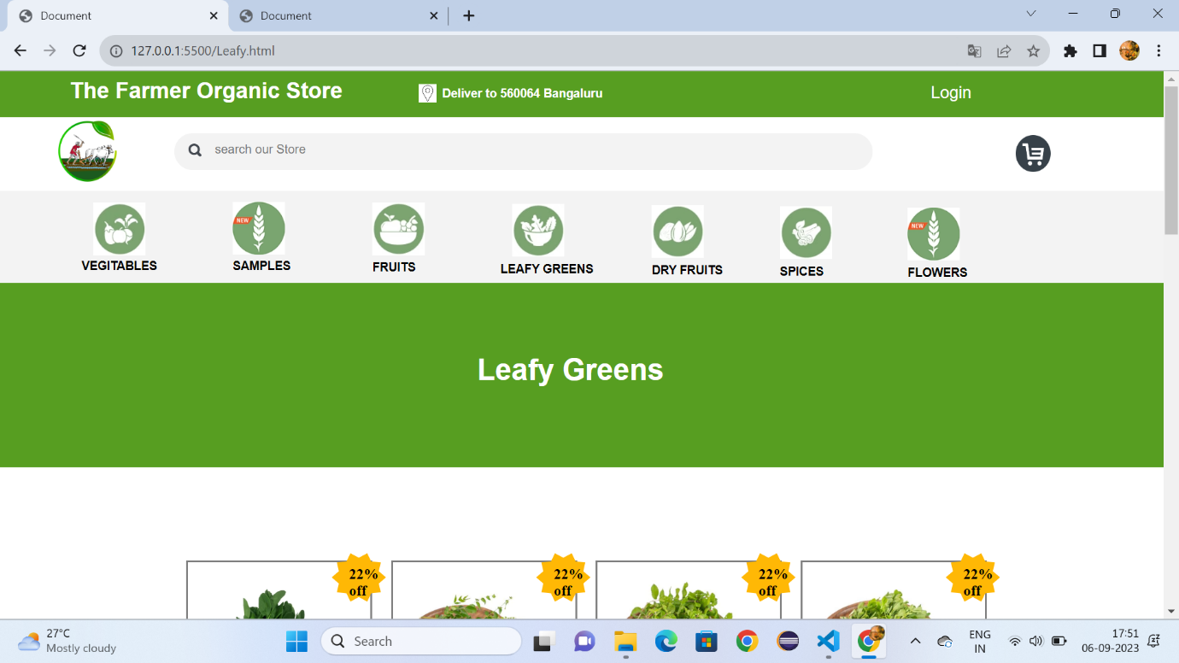

Fig:5.1

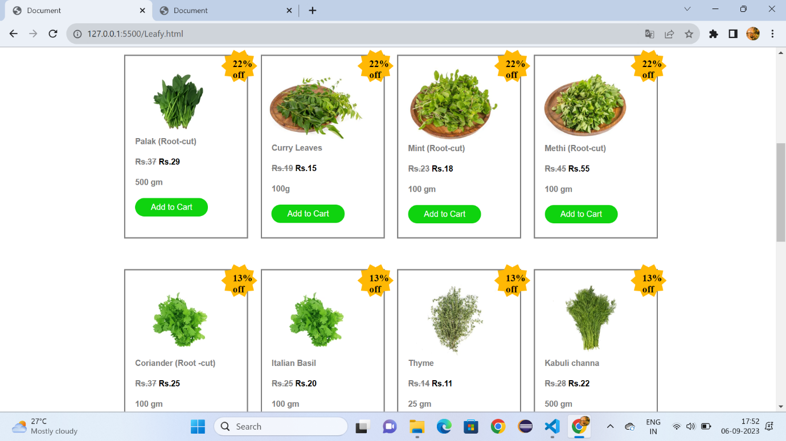

Fig:5.2

**Dry Fruits:**

<!DOCTYPE html>

<html lang="en">

<head>

    <meta charset="UTF-8">

    <meta name="viewport" content="width=device-width, initial-scale=1.0">

    <title>Document</title>

    <link rel="stylesheet" href="sample.css">

    <style>

        *{

            margin: 0px;

            box-sizing: border-box;

        }

        .cp{

            font-size:small;

            font-family: sans-serif;

            color: gray;

            margin-left: 8%;

        }

        #a{

            height: 350px;

            background-color:rgb(3, 94, 3);

        }

        .v{

            color:white;

            text-decoration: none;

            font-size: 15px;

            font-family: sans-serif;

            margin-left: 30%;

            margin-top: 12%;

            position: absolute;

        }

    </style>

</head>

<body>

    <div id="id1">

        <h1 id="id2">The Farmer Organic Store</h1>

        <h1 id="id4">Deliver to 560064 Bangaluru</h1>

        <img id="id5" src="https://encrypted-tbn0.gstatic.com/images?q=tbn:ANd9GcSWcWFIwaZbvFXos5nhXronNlcxFZUTfopn0Q&usqp=CAU">

        <a id="id3" href="">Login</a>

     </div>

     <div id="d1">

     <a href="Formers.html"><img id="id6" src="https://i.pinimg.com/originals/36/69/ed/3669ed1bdbc3b511ecbb24ab1232dd2d.png"></a>

     <div id="d2">

         <img id="d4" src="https://gourmetgarden.in/cdn/shop/t/61/assets/header_search.svg?v=164721490308982976421646454342">

     <input id="d3" type="search" placeholder="search our Store">

     <img id="d5" src="https://encrypted-tbn0.gstatic.com/images?q=tbn:ANd9GcT05oMueo_F9aqt0U6I1fx1Lvp9IPstRwYd9_KXUnkVLQ&s">

     </div>

     </div>

     <div id="d6">

         <a class="class" href="vegitables.html" target="_self"><img class="c1" src="https://gourmetgarden.in/cdn/shop/files/5_4fab297e-c32f-4262-92b1-f56fb146a6c4-min.jpg?v=1637668254">

         <figcaption class="c2"><b>VEGITABLES</b></figcaption></a>

         <a class="class" href="sample.html" target="_self"><img class="c11" src="https://gourmetgarden.in/cdn/shop/files/Web_Icon-01_1_3ae0c896-c236-4a47-a3d6-03f260637e96.jpg?v=1667834188">

         <figcaption class="c22"><b>SAMPLES</b></figcaption></a>

         <a class="class" href="Fruits.html" target="_self"><img class="c111" src="https://gourmetgarden.in/cdn/shop/files/2-compress-min.jpg?v=1637668281">

         <figcaption class="c222"><b>FRUITS</b></figcaption></a>

         <a class="class" href="Leafy.html"><img class="c111" style="margin-left: 44%;" src="https://gourmetgarden.in/cdn/shop/files/1-compress-min.jpg?v=1637668306">

         <figcaption class="c222" style="margin-left: 43%;"><b>LEAFY GREENS</b></figcaption></a>

         <a class="class" href="Dryfruits.html"><img class="c111" style="margin-left: 56%;margin-top: -7.1%;" src="https://gourmetgarden.in/cdn/shop/files/3-compress-min.jpg?v=1637668376">

         <figcaption class="c222" style="margin-left: 56%;margin-top: -1.1%;"><b>DRY FRUITS</b></figcaption></a>

         <a class="class" href="spices.html"><img class="c111" style="margin-left: 67%;margin-top: -7.1%;" src="https://gourmetgarden.in/cdn/shop/files/4-min.jpg?v=1637668400">

         <figcaption class="c222" style="margin-left: 67%;margin-top: -1.1%;"><b>SPICES</b></figcaption></a>

         <a class="class" href="flowers.html"><img class="c111" style="margin-left: 78%;margin-top: -7.1%;" src="https://gourmetgarden.in/cdn/shop/files/Web_Icon-01_1_3ae0c896-c236-4a47-a3d6-03f260637e96.jpg?v=1667834188">

         <figcaption class="c222" style="margin-left: 78%;margin-top: -1.1%;"><b>FLOWERS</b></figcaption></a>

     </div>

    <div style="height: 200px;background-color:#579e21;">

        <h1 style="font-family: sans-serif;font-size: xx-large;color: white;margin-left: 40%;padding-top:6%;">Dry Fruits & Nuts</h1>

    </div>

    <div  style="width:80%;height:1200px;margin-left: 12%;">

        <div style="width: 20%;height: 300px;border: solid gray;margin-top: 10%;margin-left: 5%;">

        <img style="width: 80%;margin-top: 10%;margin-left: 5%;" src="https://gourmetgarden.in/cdn/shop/products/cashewsclassic2_ddc84689-e67c-4832-803f-1daf3bbf6b21_360x.jpg?v=1630067645">

        <img style="margin-left:-1%;margin-top: -10px;position: absolute;" src="https://cdn.shopify.com/s/files/1/0275/8020/3094/files/Star.svg?v=1633924464"><b style="margin-left:0.5%;margin-top: 4px;position: absolute;">13%<br>off</b>

        <h1 class="cp">Classic Casews</h1>

        <br>

        <h1 class="cp"><b style="color: black;">Rs.279</b></h1>

        <br>

        <h1 class="cp">500 gm </h1>

        <br>

        <input style="border-radius: 50px;background-color:rgb(15, 211, 15);color: white;border: none;width: 60%;height: 30px;margin-left: 8%;" type="button" value="Add to Cart">

        </div>

        <div style="width: 20%;height: 300px;border: 2px solid gray;margin-left: 27%;margin-top: -300px;">

            <img style="width: 80%;margin-top: 10%;margin-left: 5%;" src="https://gourmetgarden.in/cdn/shop/products/almondsclassic2_360x.jpg?v=1641747576">

            <img style="margin-left:-1%;margin-top: -10px;position: absolute;" src="https://cdn.shopify.com/s/files/1/0275/8020/3094/files/Star.svg?v=1633924464"><b style="margin-left:0.5%;margin-top: 4px;position: absolute;">13%<br>off</b>

            <h1 class="cp">Classic Almondas</h1>

            <br>

            <h1 class="cp"><b style="color: black;">218</b></h1>

            <br>

            <h1 class="cp">200g</h1>

            <br>

            <input style="border-radius: 50px;background-color:rgb(15, 211, 15);color: white;border: none;width: 60%;height: 30px;margin-left: 8%;" type="button" value="Add to Cart">

        </div>

        <div style="width: 20%;height: 300px;border: 2px solid grey;margin-left: 49%;margin-top: -300px;">

            <img style="width: 80%;margin-top: 10%;margin-left: 5%;height: 120px;" src="https://gourmetgarden.in/cdn/shop/products/figsdried2_8c58a4ae-04c8-4aaa-ae6d-9b197b0eff85_360x.jpg?v=1641751951">

            <img style="margin-left:-1%;margin-top: -10px;position: absolute;" src="https://cdn.shopify.com/s/files/1/0275/8020/3094/files/Star.svg?v=1633924464"><b style="margin-left:0.5%;margin-top: 4px;position: absolute;">13%<br>off</b>

            <h1 class="cp">Super Premium Figs</h1>

            <br>

            <h1 class="cp"><b style="color: black;">Rs.475</b></h1>

            <br>

            <h1 class="cp">200 gm</h1>

            <br>

            <input style="border-radius: 50px;background-color:rgb(15, 211, 15);color: white;border: none;width: 60%;height: 30px;margin-left: 8%;" type="button" value="Add to Cart">

        </div>

        <div style="width: 20%;height: 300px;border: 2px solid grey;margin-left: 71%;margin-top: -300px;">

            <img style="width: 80%;margin-top: 10%;margin-left: 5%;height: 120px;" src="https://gourmetgarden.in/cdn/shop/products/almondsmamra2_360x.jpg?v=1641747628">

            <img style="margin-left:-1%;margin-top: -10px;position: absolute;" src="https://cdn.shopify.com/s/files/1/0275/8020/3094/files/Star.svg?v=1633924464"><b style="margin-left:0.5%;margin-top: 4px;position: absolute;">13%<br>off</b>

            <h1 class="cp">Mamra Almonds</h1>

            <br>

            <h1 class="cp"><b style="color: black;">Rs.425</b></h1>

            <br>

            <h1 class="cp">100 gm</h1>

            <br>

            <input style="border-radius: 50px;background-color:rgb(15, 211, 15);color: white;border: none;width: 60%;height: 30px;margin-left: 8%;" type="button" value="Add to Cart">

        </div>

        <div style="width: 20%;height: 300px;border: solid grey;margin-top: 5%;margin-left: 5%;">

            <img style="width: 80%;margin-top: 10%;margin-left: 5%;height: 120px;" src="https://gourmetgarden.in/cdn/shop/products/walnut_582422d5-110d-42b3-ae05-287a8bad3164_360x.jpg?v=1630068370">

            <img style="margin-left:-1%;margin-top: -10px;position: absolute;" src="https://cdn.shopify.com/s/files/1/0275/8020/3094/files/Star.svg?v=1633924464"><b style="margin-left:0.5%;margin-top: 4px;position: absolute;">13%<br>off</b>

            <h1 class="cp">Super Premium Walnuts-California</h1>

            <br>

            <h1 class="cp"><b style="color: black;">Rs.445</b></h1>

            <br>

            <h1 class="cp">200 gm </h1>

            <br>

            <input style="border-radius: 50px;background-color:rgb(15, 211, 15);color: white;border: none;width: 60%;height: 30px;margin-left: 8%;" type="button" value="Add to Cart">

        </div>

        <div style="width: 20%;height: 300px;border: 2px solid grey;margin-left: 27%;margin-top: -300px;">

            <img style="width: 80%;margin-top: 10%;margin-left: 5%;height: 120px;" src="https://gourmetgarden.in/cdn/shop/products/pecans2_e04bef19-93a4-479f-b676-046456c6abb0_360x.jpg?v=1630068123">

            <img style="margin-left:-1%;margin-top: -10px;position: absolute;" src="https://cdn.shopify.com/s/files/1/0275/8020/3094/files/Star.svg?v=1633924464"><b style="margin-left:0.5%;margin-top: 4px;position: absolute;">13%<br>off</b>

            <h1 class="cp">Pecans-California</h1>

            <br>

            <h1 class="cp"><b style="color: black;">Rs.370</b></h1>

            <br>

            <h1 class="cp">500 gm </h1>

            <br>

            <input style="border-radius: 50px;background-color:rgb(15, 211, 15);color: white;border: none;width: 60%;height: 30px;margin-left: 8%;" type="button" value="Add to Cart">

        </div>

        <div style="width: 20%;height: 300px;border: 2px solid grey;margin-left: 49%;margin-top: -300px;">

            <img style="width: 80%;margin-top: 10%;margin-left: 5%;height: 120px;" src="https://gourmetgarden.in/cdn/shop/products/hazelnutscalifornia_360x.jpg?v=1630694564">

            <img style="margin-left:-1%;margin-top: -10px;position: absolute;" src="https://cdn.shopify.com/s/files/1/0275/8020/3094/files/Star.svg?v=1633924464"><b style="margin-left:0.5%;margin-top: 4px;position: absolute;">13%<br>off</b>

            <h1 class="cp">Hezelnuts-California</h1>

            <br>

            <h1 class="cp"><b style="color: black;">Rs.230</b></h1>

            <br>

            <h1 class="cp">500 gm </h1>

            <br>

            <input style="border-radius: 50px;background-color:rgb(15, 211, 15);color: white;border: none;width: 60%;height: 30px;margin-left: 8%;" type="button" value="Add to Cart">

        </div>

        <div style="width: 20%;height: 300px;border: 2px solid grey;margin-left: 71%;margin-top: -300px;">

            <img style="width: 80%;margin-top: 10%;margin-left: 5%;height: 120px;" src="https://gourmetgarden.in/cdn/shop/products/sunflowerseedsde-shelled2_4c63eb6f-65aa-413c-b4c1-7dd00f873cc7_360x.jpg?v=1630068394">

            <img style="margin-left:-1%;margin-top: -10px;position: absolute;" src="https://cdn.shopify.com/s/files/1/0275/8020/3094/files/Star.svg?v=1633924464"><b style="margin-left:0.5%;margin-top: 4px;position: absolute;">13%<br>off</b>

            <h1 class="cp">Sunflower Seeds</h1>

            <br>

            <h1 class="cp"><b style="color: black;">Rs.75</b></h1>

            <br>

            <h1 class="cp">500 gm </h1>

            <br>

            <input style="border-radius: 50px;background-color:rgb(15, 211, 15);color: white;border: none;width: 60%;height: 30px;margin-left: 8%;" type="button" value="Add to Cart">

        </div>

        <div style="width: 20%;height: 300px;border: solid grey;margin-top: 5%;margin-left: 5%;">

            <img style="width: 80%;margin-top: 10%;margin-left: 5%;" src="https://gourmetgarden.in/cdn/shop/products/raisinsgreenafghan2_432cba75-17da-4104-9878-f52c9db30e1b_360x.jpg?v=1630068380">

            <img style="margin-left:-1%;margin-top: -10px;position: absolute;" src="https://cdn.shopify.com/s/files/1/0275/8020/3094/files/Star.svg?v=1633924464"><b style="margin-left:0.5%;margin-top: 4px;position: absolute;">13%<br>off</b>

            <h1 class="cp">Super Permium Green</h1>

            <br>

            <h1 class="cp"><b style="color: black;">Rs.299</b></h1>

            <br>

            <h1 class="cp">500 gm </h1>

            <br>

            <input style="border-radius: 50px;background-color:rgb(15, 211, 15);color: white;border: none;width: 60%;height: 30px;margin-left: 8%;" type="button" value="Add to Cart">

        </div>

        <div style="width: 20%;height: 300px;border: 2px solid grey;margin-left: 27%;margin-top: -300px;">

            <img style="width: 80%;margin-top: 10%;margin-left: 5%;" src="https://gourmetgarden.in/cdn/shop/products/Pistachios_360x.jpg?v=1637502066">

            <img style="margin-left:-1%;margin-top: -10px;position: absolute;" src="https://cdn.shopify.com/s/files/1/0275/8020/3094/files/Star.svg?v=1633924464"><b style="margin-left:0.5%;margin-top: 4px;position: absolute;">13%<br>off</b>

            <h1 class="cp">Super Premium Salted</h1>

            <br>

            <h1 class="cp"><b style="color: black;">Rs.389</b></h1>

            <br>

            <h1 class="cp">500 gm </h1>

            <br>

            <input style="border-radius: 50px;background-color:rgb(15, 211, 15);color: white;border: none;width: 60%;height: 30px;margin-left: 8%;" type="button" value="Add to Cart">

        </div>

        <div style="width: 20%;height: 300px;border: 2px solid grey;margin-left: 49%;margin-top: -300px;">

            <img style="width: 80%;margin-top: 10%;margin-left: 5%;height: 120px;" src="https://gourmetgarden.in/cdn/shop/products/watermelonseedsde-shelled_066d462e-a902-4827-896b-61b9948188af_360x.jpg?v=1630068363">

            <img style="margin-left:-1%;margin-top: -10px;position: absolute;" src="https://cdn.shopify.com/s/files/1/0275/8020/3094/files/Star.svg?v=1633924464"><b style="margin-left:0.5%;margin-top: 4px;position: absolute;">13%<br>off</b>

            <h1 class="cp">Watermelon seeds</h1>

            <br>

            <h1 class="cp"><b style="color: black;">Rs.200</b></h1>

            <br>

            <h1 class="cp">500 gm </h1>

            <br>

            <input style="border-radius: 50px;background-color:rgb(15, 211, 15);color: white;border: none;width: 60%;height: 30px;margin-left: 8%;" type="button" value="Add to Cart">

        </div>

        <div style="width: 20%;height: 300px;border: 2px solid grey;margin-left: 71%;margin-top: -300px;">

            <img style="width: 80%;margin-top: 10%;margin-left: 5%;height: 120px;" src="https://gourmetgarden.in/cdn/shop/products/raisinsclassic_360x.jpg?v=1630694613">

            <img style="margin-left:-1%;margin-top: -10px;position: absolute;" src="https://cdn.shopify.com/s/files/1/0275/8020/3094/files/Star.svg?v=1633924464"><b style="margin-left:0.5%;margin-top: 4px;position: absolute;">13%<br>off</b>

            <h1 class="cp">Pine Nuts (Peeled)-Californiya</h1>

            <br>

            <h1 class="cp"><b style="color: black;">Rs.475</b></h1>

            <br>

            <h1 class="cp">500 gm </h1>

            <br>

            <input style="border-radius: 50px;background-color:rgb(15, 211, 15);color: white;border: none;width: 60%;height: 30px;margin-left: 8%;" type="button" value="Add to Cart">

        </div>

       </div>

       <div id="a">

        <img style="width: 60px;height: 60px;border-radius: 100px;position: absolute;margin-left: 43%;margin-top: 2%;" src="https://encrypted-tbn0.gstatic.com/images?q=tbn:ANd9GcQYYPsOYQ26sdslJ8sbWSKA6oskWX0R2W5bCg&usqp=CAU"><b style="font-family: sans-serif;font-size: large;margin-left: 40%;margin-top: 8%;position: absolute;color: white;">Indian Farmers</b>

        <a style="padding-left: 80px;" class="v" href=""><b>Terms</b></a>

        <a style="padding-left: 160px;" class="v" href=""><b>About</b></a>

        <a style="padding-left: 240px;" class="v" href=""><b>Privacy</b></a>

        <img style="padding-left: 34%;margin-top: 20%;" src="https://gourmetgarden.in/cdn/shop/t/61/assets/footer_fb_icon.svg?v=110095049522194708271646454327">&nbsp;&nbsp;&nbsp;&nbsp;

        <img src="https://gourmetgarden.in/cdn/shop/t/61/assets/footer_ig_icon.svg?v=110514061604159201831646454328">&nbsp;&nbsp;&nbsp;&nbsp;

        <img style="height: 30px;" src="https://cdn.shopify.com/s/files/1/0628/9725/8731/files/andoid-btn.png?v=1647696676">&nbsp;&nbsp;&nbsp;&nbsp;

        <img style="height: 30px;" src="https://cdn.shopify.com/s/files/1/0628/9725/8731/files/ios-btn.png?v=1647696676">

        <hr style="margin-top: -60px;">

    </div>

</body>

</html>

**Dry Fruits.css:**

#id1{

    height: 50px;

    background-color:#579e21;

    border: none;

    width: 100%;

}

#id2{

    padding-top:0.6%;

    color: white;

    font-family: sans-serif;

    font-size: x-large;

    padding-left: 6%;

}

#id3{

    color:white;

    font-family: sans-serif;

   margin-top: -1.5%;

   position: absolute;

   text-decoration: none;

   font-size: large;

   margin-left: 80%;

}

#id4{

    color: white;

    margin-top: -2%;

    font-size: small;

    font-family: sans-serif;

    margin-left: 38%;

    margin-top: -1.5%;

}

#id5{

    width: 1.5%;

    height: 20px;

    margin-top: -10%;

    margin-left: 36%;

    margin-top: -1.4%;

    position: absolute;

}

#id6{

    width: 5%;

   height: 70px;

   margin-left: 5%;

   padding-top: 0.3%;

}

#d1{

    height: 80px;

}

#d2{

    border-radius: 50px;

    width: 60%;

    height: 40px;

    margin-top: -4.5%;

    margin-left: 15%;

    background-color: rgb(243, 243, 243);

}

#d3{

    outline: none;

    border: none;

    margin-left: 1%;

    background-color: rgb(243, 243, 243);

    padding-top: 0.8%;

    position: absolute;

}

#d4{

    margin-left: 2%;

    padding-top: 1.5%;

}

#d5{

    width: 3%;

    height: 40px;

    margin-left: 70%;

    position: absolute;

    margin-top: 2px;

}

#d6{

    height: 100px;

    background-color:rgb(243, 243, 243) ;

}

.c1{

    padding-top: 1%;

    width: 4.5%;

    height: 70px;

    margin-left: 8%;

}

.c2{

    font-family: sans-serif;

    font-size: small;

    margin-left: 7%;

}

.c11{

    padding-top: 1%;

    width: 4.5%;

    height: 70px;

    margin-left: 20%;

    margin-top: -7.1%;

    position: absolute;

}

.c22{

    font-family: sans-serif;

    font-size: small;

    margin-left: 20%;

    margin-top: -1.2%;

}

.c111{

    padding-top: 1%;

    width: 4.5%;

    height: 70px;

    margin-left: 32%;

    margin-top: -7.1%;

    position: absolute;

}

.c222{

    font-family: sans-serif;

    font-size: small;

    margin-left: 32%;

    margin-top: -1.1%;

}

.class{

    text-decoration: none;

    color: black;

    }

**Output:**

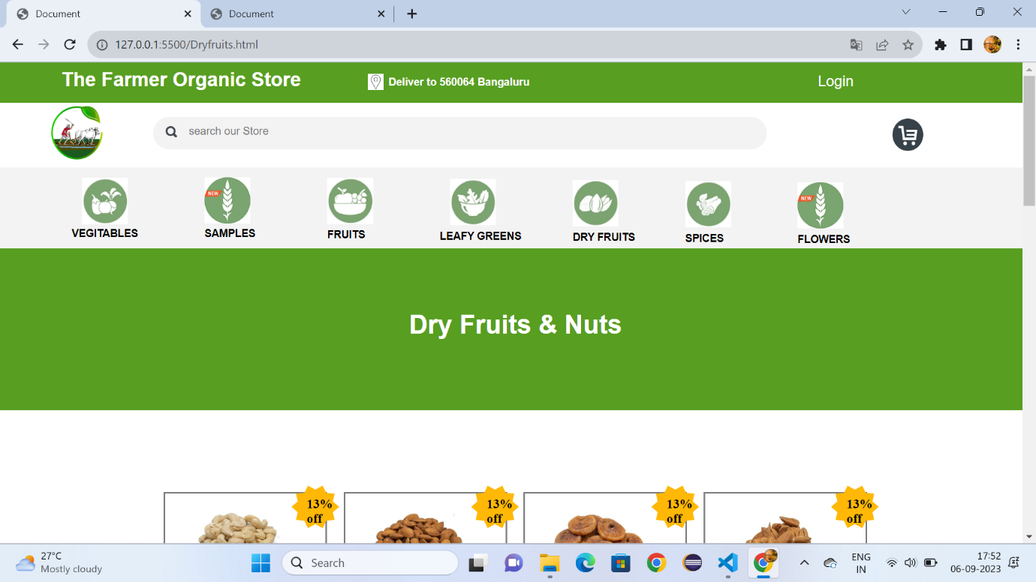

Fig6.1

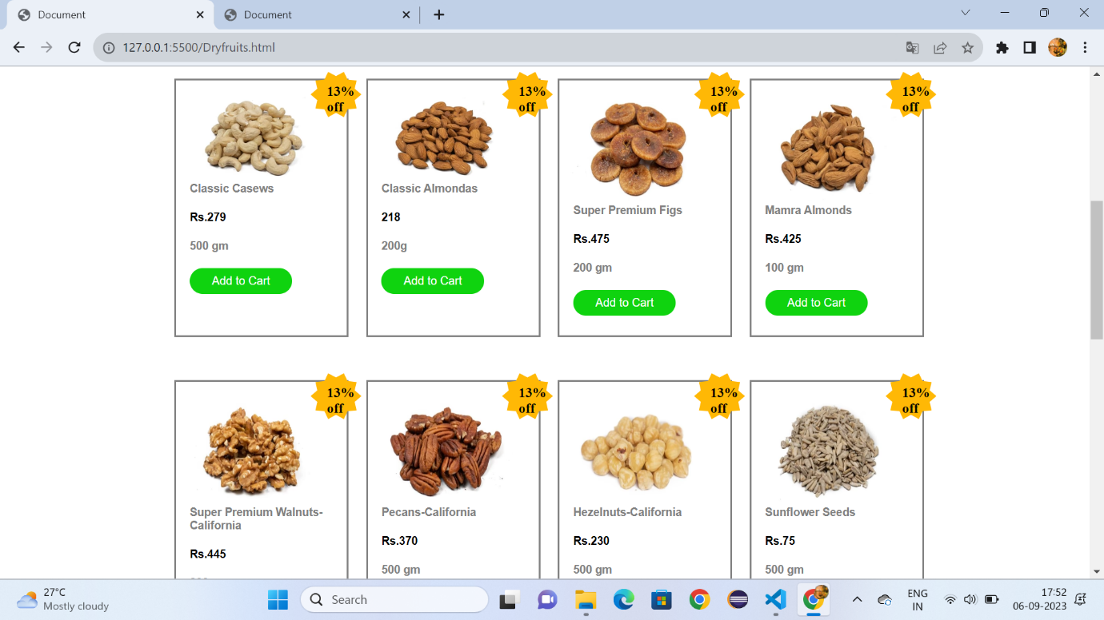

Fig:6.2

**Spices.html\InlineCSS**

<!DOCTYPE html>

<html lang="en">

<head>

    <meta charset="UTF-8">

    <meta name="viewport" content="width=device-width, initial-scale=1.0">

    <title>Document</title>

    <link rel="stylesheet" href="vegetable.css">

    <style>

        *{

            margin: 0px;

            box-sizing: border-box;

        }

        .cp{

            font-size:small;

            font-family: sans-serif;

            color: gray;

            margin-left: 8%;

        }

        #a{

            height: 350px;

            background-color:rgb(3, 94, 3);

        }

        .v{

            color:white;

            text-decoration: none;

            font-size: 15px;

            font-family: sans-serif;

            margin-left: 30%;

            margin-top: 12%;

            position: absolute;

        }

    </style>

</head>

<body>

    <div id="id1">

        <h1 id="id2">The Farmer Organic Store</h1>

        <h1 id="id4">Deliver to 560064 Bangaluru</h1>

        <img id="id5" src="https://encrypted-tbn0.gstatic.com/images?q=tbn:ANd9GcSWcWFIwaZbvFXos5nhXronNlcxFZUTfopn0Q&usqp=CAU">

        <a id="id3" href="">Login</a>

     </div>

     <div id="d1">

     <a href="Formers.html"><img id="id6" src="https://i.pinimg.com/originals/36/69/ed/3669ed1bdbc3b511ecbb24ab1232dd2d.png"></a>

     <div id="d2">

         <img id="d4" src="https://gourmetgarden.in/cdn/shop/t/61/assets/header_search.svg?v=164721490308982976421646454342">

     <input id="d3" type="search" placeholder="search our Store">

     <img id="d5" src="https://encrypted-tbn0.gstatic.com/images?q=tbn:ANd9GcT05oMueo_F9aqt0U6I1fx1Lvp9IPstRwYd9_KXUnkVLQ&s">

     </div>

     </div>

     <div id="d6">

         <a class="class" href="vegitables.html" target="_self"><img class="c1" src="https://gourmetgarden.in/cdn/shop/files/5_4fab297e-c32f-4262-92b1-f56fb146a6c4-min.jpg?v=1637668254">

         <figcaption class="c2"><b>VEGITABLES</b></figcaption></a>

         <a class="class" href="sample.html" target="_self"><img class="c11" src="https://gourmetgarden.in/cdn/shop/files/Web_Icon-01_1_3ae0c896-c236-4a47-a3d6-03f260637e96.jpg?v=1667834188">

         <figcaption class="c22"><b>SAMPLES</b></figcaption></a>

         <a class="class" href="Fruits.html" target="_self"><img class="c111" src="https://gourmetgarden.in/cdn/shop/files/2-compress-min.jpg?v=1637668281">

         <figcaption class="c222"><b>FRUITS</b></figcaption></a>

         <a class="class" href="Leafy.html"><img class="c111" style="margin-left: 44%;" src="https://gourmetgarden.in/cdn/shop/files/1-compress-min.jpg?v=1637668306">

         <figcaption class="c222" style="margin-left: 43%;"><b>LEAFY GREENS</b></figcaption></a>

         <a class="class" href="Dryfruits.html"><img class="c111" style="margin-left: 56%;margin-top: -7.1%;" src="https://gourmetgarden.in/cdn/shop/files/3-compress-min.jpg?v=1637668376">

         <figcaption class="c222" style="margin-left: 56%;margin-top: -1.1%;"><b>DRY FRUITS</b></figcaption></a>

         <a class="class" href="spices.html"><img class="c111" style="margin-left: 67%;margin-top: -7.1%;" src="https://gourmetgarden.in/cdn/shop/files/4-min.jpg?v=1637668400">

         <figcaption class="c222" style="margin-left: 67%;margin-top: -1.1%;"><b>SPICES</b></figcaption></a>

         <a class="class" href="flowers.html"><img class="c111" style="margin-left: 78%;margin-top: -7.1%;" src="https://gourmetgarden.in/cdn/shop/files/Web_Icon-01_1_3ae0c896-c236-4a47-a3d6-03f260637e96.jpg?v=1667834188">

         <figcaption class="c222" style="margin-left: 78%;margin-top: -1.1%;"><b>FLOWERS</b></figcaption></a>

     </div>

    <div style="height: 200px;background-color:#579e21;">

        <h1 style="font-family: sans-serif;font-size: xx-large;color: white;margin-left: 40%;padding-top:6%;">Authentic Spices</h1>

    </div>

    <div  style="width:80%;height:1200px;margin-left: 12%;">

        <div style="width: 20%;height: 300px;border: solid gray;margin-top: 10%;margin-left: 5%;">

        <img style="width: 80%;margin-top: 10%;margin-left: 5%;" src="https://gourmetgarden.in/cdn/shop/products/Himaliya-Salt_360x.png?v=1655698609">

        <h1 class="cp">Himalayan Pink Salt</h1>

        <br>

        <h1 class="cp" ><b style="color: black;">Rs.88</b></h1>

        <br>

        <h1 class="cp">500 gm </h1>

        <br>

        <input style="border-radius: 50px;background-color:rgb(15, 211, 15);color: white;border: none;width: 60%;height: 30px;margin-left: 8%;" type="button" value="Add to Cart">

        </div>

        <div style="width: 20%;height: 300px;border: 2px solid gray;margin-left: 27%;margin-top: -300px;">

            <img style="width: 80%;margin-top: 10%;margin-left: 5%;" src="https://gourmetgarden.in/cdn/shop/products/jeera_144a039e-467a-472f-a51f-6f89532738d5_360x.jpg?v=1630066617">

            <h1 class="cp">Cumin (Jeera) Seeds</h1>

            <br>

            <h1 class="cp"><b style="color: black;">Rs.145</b></h1>

            <br>

            <h1 class="cp">500g</h1>

            <br>

            <input style="border-radius: 50px;background-color:rgb(15, 211, 15);color: white;border: none;width: 60%;height: 30px;margin-left: 8%;" type="button" value="Add to Cart">

        </div>

        <div style="width: 20%;height: 300px;border: 2px solid grey;margin-left: 49%;margin-top: -300px;">

            <img style="width: 80%;margin-top: 10%;margin-left: 5%;height: 120px;" src="https://gourmetgarden.in/cdn/shop/products/bayleaf2_d0529fd6-62f7-4664-95c3-938d3a8b6722_360x.jpg?v=1630066187">

            <h1 class="cp">Bay Leaf (Tej Patta)</h1>

            <br>

            <h1 class="cp"><b style="color: black;">Rs.55</b></h1>

            <br>

            <h1 class="cp">500 gm</h1>

            <br>

            <input style="border-radius: 50px;background-color:rgb(15, 211, 15);color: white;border: none;width: 60%;height: 30px;margin-left: 8%;" type="button" value="Add to Cart">

        </div>

        <div style="width: 20%;height: 300px;border: 2px solid grey;margin-left: 71%;margin-top: -300px;">

            <img style="width: 80%;margin-top: 10%;margin-left: 5%;height: 120px;" src="https://gourmetgarden.in/cdn/shop/products/pepperblack2_8578b3e5-664a-4eeb-8301-def11df82397_360x.jpg?v=1630066686">

            <h1 class="cp">Black Papper</h1>

            <br>

            <h1 class="cp"><b style="color: black;">Rs.55</b></h1>

            <br>

            <h1 class="cp">500 gm</h1>

            <br>

            <input style="border-radius: 50px;background-color:rgb(15, 211, 15);color: white;border: none;width: 60%;height: 30px;margin-left: 8%;" type="button" value="Add to Cart">

        </div>

        <div style="width: 20%;height: 300px;border: solid grey;margin-top: 5%;margin-left: 5%;">

            <img style="width: 80%;margin-top: 10%;margin-left: 5%;height: 120px;" src="https://gourmetgarden.in/cdn/shop/products/turmericground_47c4472c-e688-428a-850b-7445ec680126_360x.jpg?v=1630067393">

            <h1 class="cp">Turmeric Powder-Salem</h1>

            <br>

            <h1 class="cp"><b style="color: black;">Rs.25</b></h1>

            <br>

            <h1 class="cp">500 gm </h1>

            <br>

            <input style="border-radius: 50px;background-color:rgb(15, 211, 15);color: white;border: none;width: 60%;height: 30px;margin-left: 8%;" type="button" value="Add to Cart">

        </div>

        <div style="width: 20%;height: 300px;border: 2px solid grey;margin-left: 27%;margin-top: -300px;">

            <img style="width: 80%;margin-top: 10%;margin-left: 5%;height: 120px;" src="https://gourmetgarden.in/cdn/shop/products/chillibyadgi2_1_540x.jpg?v=1630694948">

            <h1 class="cp">Byadgi chilli</h1>

            <br>

            <h1 class="cp"><b style="color: black;">Rs.45</b></h1>

            <br>

            <h1 class="cp">500 gm </h1>

            <br>

            <input style="border-radius: 50px;background-color:rgb(15, 211, 15);color: white;border: none;width: 60%;height: 30px;margin-left: 8%;" type="button" value="Add to Cart">

        </div>

        <div style="width: 20%;height: 300px;border: 2px solid grey;margin-left: 49%;margin-top: -300px;">

            <img style="width: 80%;margin-top: 10%;margin-left: 5%;height: 120px;" src="https://gourmetgarden.in/cdn/shop/products/corianderseedsground2_ac2db10c-3d43-40c5-8fcf-2bdb8f3fdba1_360x.jpg?v=1630066412">

            <h1 class="cp"> Coriander Powder</h1>

            <br>

            <h1 class="cp"><b style="color: black;">Rs.50</b></h1>

            <br>

            <h1 class="cp">500 gm </h1>

            <br>

            <input style="border-radius: 50px;background-color:rgb(15, 211, 15);color: white;border: none;width: 60%;height: 30px;margin-left: 8%;" type="button" value="Add to Cart">

        </div>

        <div style="width: 20%;height: 300px;border: 2px solid grey;margin-left: 71%;margin-top: -300px;">

            <img style="width: 80%;margin-top: 10%;margin-left: 5%;height: 120px;" src="https://gourmetgarden.in/cdn/shop/products/staranise_35f8fcea-6a7d-43eb-80f9-bd785af0aaed_360x.jpg?v=1630067284">

            <h1 class="cp">Star Anise-vietnam</h1>

            <br>

            <h1 class="cp"><b style="color: black;">Rs.22</b></h1>

            <br>

            <h1 class="cp">500 gm </h1>

            <br>

            <input style="border-radius: 50px;background-color:rgb(15, 211, 15);color: white;border: none;width: 60%;height: 30px;margin-left: 8%;" type="button" value="Add to Cart">

        </div>

        <div style="width: 20%;height: 300px;border: solid grey;margin-top: 5%;margin-left: 5%;">

            <img style="width: 80%;margin-top: 10%;margin-left: 5%;" src="https://gourmetgarden.in/cdn/shop/products/cinnamoncigarsceylon2_9b582255-d8bc-45a3-858c-767c6a54343c_540x.jpg?v=1630066370">

            <h1 class="cp">Ceylon Cinnamon Cigars</h1>

            <br>

            <h1 class="cp"><b style="color: black;">Rs.55</b></h1>

            <br>

            <h1 class="cp">500 gm </h1>

            <br>

            <input style="border-radius: 50px;background-color:rgb(15, 211, 15);color: white;border: none;width: 60%;height: 30px;margin-left: 8%;" type="button" value="Add to Cart">

        </div>

        <div style="width: 20%;height: 300px;border: 2px solid grey;margin-left: 27%;margin-top: -300px;">

            <img style="width: 80%;margin-top: 10%;margin-left: 5%;" src="https://gourmetgarden.in/cdn/shop/products/cloves2_98a568dc-3f60-445f-968a-b5b369f1507c_360x.jpg?v=1630066360">

            <h1 class="cp">Clovers-Indonesia</h1>

            <br>

            <h1 class="cp"><b style="color: black;">Rs.55</b></h1>

            <br>

            <h1 class="cp">500 gm </h1>

            <br>

            <input style="border-radius: 50px;background-color:rgb(15, 211, 15);color: white;border: none;width: 60%;height: 30px;margin-left: 8%;" type="button" value="Add to Cart">

        </div>

        <div style="width: 20%;height: 300px;border: 2px solid grey;margin-left: 49%;margin-top: -300px;">

            <img style="width: 80%;margin-top: 10%;margin-left: 5%;height: 120px;" src="https://gourmetgarden.in/cdn/shop/products/cardamom2_19cf63be-8ec8-4b2b-ab90-fa5fc79ab284_360x.jpg?v=1641750476">

            <h1 class="cp">Green Cardanom</h1>

            <br>

            <h1 class="cp"><b style="color: black;">Rs.20</b></h1>

            <br>

            <h1 class="cp">500 gm </h1>

            <br>

            <input style="border-radius: 50px;background-color:rgb(15, 211, 15);color: white;border: none;width: 60%;height: 30px;margin-left: 8%;" type="button" value="Add to Cart">

        </div>

        <div style="width: 20%;height: 300px;border: 2px solid grey;margin-left: 71%;margin-top: -300px;">

            <img style="width: 80%;margin-top: 10%;margin-left: 5%;height: 120px;" src="https://gourmetgarden.in/cdn/shop/products/chilliguntur_360x.jpg?v=1630694839">

            <h1 class="cp">Guntur Chill</h1>

            <br>

            <h1 class="cp"><b style="color: black;">Rs.20</b></h1>

            <br>

            <h1 class="cp">500 gm </h1>

            <br>

            <input style="border-radius: 50px;background-color:rgb(15, 211, 15);color: white;border: none;width: 60%;height: 30px;margin-left: 8%;" type="button" value="Add to Cart">

        </div>

       </div>

       <div id="a">

        <img style="width: 60px;height: 60px;border-radius: 100px;position: absolute;margin-left: 43%;margin-top: 2%;" src="https://encrypted-tbn0.gstatic.com/images?q=tbn:ANd9GcQYYPsOYQ26sdslJ8sbWSKA6oskWX0R2W5bCg&usqp=CAU"><b style="font-family: sans-serif;font-size: large;margin-left: 40%;margin-top: 8%;position: absolute;color: white;">Indian Farmers</b>

        <a style="padding-left: 80px;" class="v" href=""><b>Terms</b></a>

        <a style="padding-left: 160px;" class="v" href=""><b>About</b></a>

        <a style="padding-left: 240px;" class="v" href=""><b>Privacy</b></a>

        <img style="padding-left: 34%;margin-top: 20%;" src="https://gourmetgarden.in/cdn/shop/t/61/assets/footer_fb_icon.svg?v=110095049522194708271646454327">&nbsp;&nbsp;&nbsp;&nbsp;

        <img src="https://gourmetgarden.in/cdn/shop/t/61/assets/footer_ig_icon.svg?v=110514061604159201831646454328">&nbsp;&nbsp;&nbsp;&nbsp;

        <img style="height: 30px;" src="https://cdn.shopify.com/s/files/1/0628/9725/8731/files/andoid-btn.png?v=1647696676">&nbsp;&nbsp;&nbsp;&nbsp;

        <img style="height: 30px;" src="https://cdn.shopify.com/s/files/1/0628/9725/8731/files/ios-btn.png?v=1647696676">

        <hr style="margin-top: -60px;">

    </div>

</body>

</html>

**Output:**

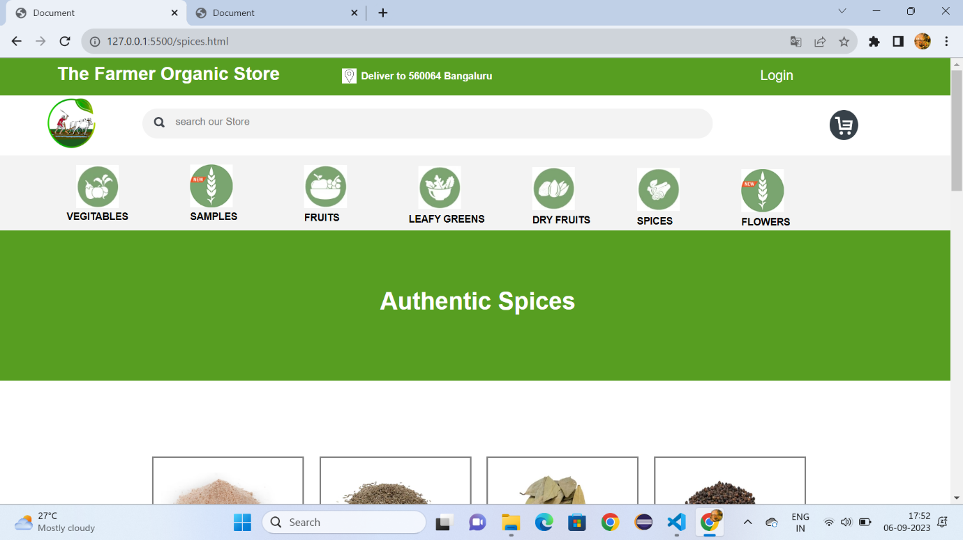

Fig:7.1

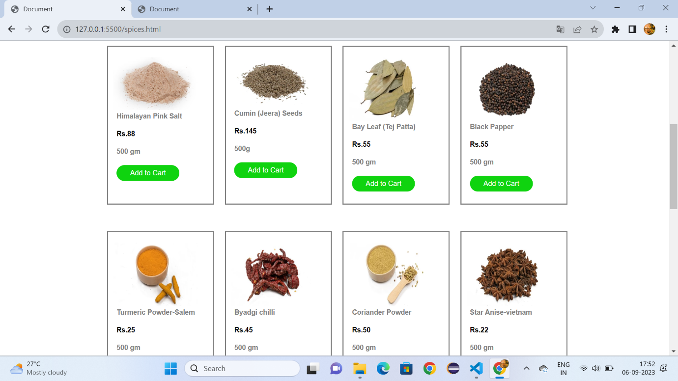

Fig:7.2

**Flowers.html:**

<!DOCTYPE html>

<html lang="en">

<head>

    <meta charset="UTF-8">

    <meta name="viewport" content="width=device-width, initial-scale=1.0">

    <title>Document</title>

    <link rel="stylesheet" href="vegetable.css">

    <style>

        *{

            margin: 0px;

            box-sizing: border-box;

        }

        .cp{

            font-size:small;

            font-family: sans-serif;

            color: gray;

            margin-left: 8%;

        }

        #a{

            height: 350px;

            background-color:rgb(3, 94, 3);

        }

        .v{

            color:white;

            text-decoration: none;

            font-size: 15px;

            font-family: sans-serif;

            margin-left: 30%;

            margin-top: 12%;

            position: absolute;

        }

    </style>

</head>

<body>

    <div id="id1">

        <h1 id="id2">The Farmer Organic Store</h1>

        <h1 id="id4">Deliver to 560064 Bangaluru</h1>

        <img id="id5" src="https://encrypted-tbn0.gstatic.com/images?q=tbn:ANd9GcSWcWFIwaZbvFXos5nhXronNlcxFZUTfopn0Q&usqp=CAU">

        <a id="id3" href="">Login</a>

     </div>

     <div id="d1">

     <a href="Formers.html"><img id="id6" src="https://i.pinimg.com/originals/36/69/ed/3669ed1bdbc3b511ecbb24ab1232dd2d.png"></a>

     <div id="d2">

         <img id="d4" src="https://gourmetgarden.in/cdn/shop/t/61/assets/header_search.svg?v=164721490308982976421646454342">

     <input id="d3" type="search" placeholder="search our Store">

     <img id="d5" src="https://encrypted-tbn0.gstatic.com/images?q=tbn:ANd9GcT05oMueo_F9aqt0U6I1fx1Lvp9IPstRwYd9_KXUnkVLQ&s">

     </div>

     </div>

     <div id="d6">

         <a class="class" href="vegitables.html" target="_self"><img class="c1" src="https://gourmetgarden.in/cdn/shop/files/5_4fab297e-c32f-4262-92b1-f56fb146a6c4-min.jpg?v=1637668254">

         <figcaption class="c2"><b>VEGITABLES</b></figcaption></a>

         <a class="class" href="sample.html" target="_self"><img class="c11" src="https://gourmetgarden.in/cdn/shop/files/Web_Icon-01_1_3ae0c896-c236-4a47-a3d6-03f260637e96.jpg?v=1667834188">

         <figcaption class="c22"><b>SAMPLES</b></figcaption></a>

         <a class="class" href="Fruits.html" target="_self"><img class="c111" src="https://gourmetgarden.in/cdn/shop/files/2-compress-min.jpg?v=1637668281">

         <figcaption class="c222"><b>FRUITS</b></figcaption></a>

         <a class="class" href="Leafy.html"><img class="c111" style="margin-left: 44%;" src="https://gourmetgarden.in/cdn/shop/files/1-compress-min.jpg?v=1637668306">

         <figcaption class="c222" style="margin-left: 43%;"><b>LEAFY GREENS</b></figcaption></a>

         <a class="class" href="Dryfruits.html"><img class="c111" style="margin-left: 56%;margin-top: -7.1%;" src="https://gourmetgarden.in/cdn/shop/files/3-compress-min.jpg?v=1637668376">

         <figcaption class="c222" style="margin-left: 56%;margin-top: -1.1%;"><b>DRY FRUITS</b></figcaption></a>

         <a class="class" href="spices.html"><img class="c111" style="margin-left: 67%;margin-top: -7.1%;" src="https://gourmetgarden.in/cdn/shop/files/4-min.jpg?v=1637668400">

         <figcaption class="c222" style="margin-left: 67%;margin-top: -1.1%;"><b>SPICES</b></figcaption></a>

         <a class="class" href="flowers.html"><img class="c111" style="margin-left: 78%;margin-top: -7.1%;" src="https://gourmetgarden.in/cdn/shop/files/Web_Icon-01_1_3ae0c896-c236-4a47-a3d6-03f260637e96.jpg?v=1667834188">

         <figcaption class="c222" style="margin-left: 78%;margin-top: -1.1%;"><b>FLOWERS</b></figcaption></a>

     </div>

    <div style="height: 200px;background-color:#579e21;">

        <h1 style="font-family: sans-serif;font-size: xx-large;color: white;margin-left: 43%;padding-top:6%;">Flowers</h1>

    </div>

    <div  style="width:80%;height:1200px;margin-left: 12%;">

        <div style="width: 20%;height: 300px;border: solid gray;margin-top: 10%;margin-left: 5%;">

        <img style="width: 70%;margin-top: 10%;margin-left: 6%;height: 130px;" src="https://encrypted-tbn0.gstatic.com/images?q=tbn:ANd9GcT9yk9_UVu_iFpXAHZtNj-3TlgugpDd960Pjg&usqp=CAU">

        <h1 class="cp">Roce</h1>

        <br>

        <h1 class="cp"><b style="color: black;">Rs.88</b></h1>

        <br>

        <h1 class="cp">500 gm </h1>

        <br>

        <input style="border-radius: 50px;background-color:rgb(15, 211, 15);color: white;border: none;width: 60%;height: 30px;margin-left: 8%;" type="button" value="Add to Cart">

        </div>

        <div style="width: 20%;height: 300px;border: 2px solid gray;margin-left: 27%;margin-top: -300px;">

            <img style="width: 80%;margin-top: 10%;margin-left: 5%;" src="https://encrypted-tbn0.gstatic.com/images?q=tbn:ANd9GcSn5VRZFYkjlWV8mvWzl1WOnX0RMg_7EkScAA&usqp=CAU">

            <h1 class="cp">Hybiscus</h1>

            <br>

            <h1 class="cp"><b style="color: black;">Rs.15</b></h1>

            <br>

            <h1 class="cp">10g</h1>

            <br>

            <input style="border-radius: 50px;background-color:rgb(15, 211, 15);color: white;border: none;width: 60%;height: 30px;margin-left: 8%;" type="button" value="Add to Cart">

        </div>

        <div style="width: 20%;height: 300px;border: 2px solid grey;margin-left: 49%;margin-top: -300px;">

            <img style="width: 80%;margin-top: 10%;margin-left: 5%;height: 120px;" src="https://encrypted-tbn0.gstatic.com/images?q=tbn:ANd9GcQmr1rIj7OsoDIgrr8Mp-9kiDUgPvPSH0ANgw&usqp=CAU">

            <h1 class="cp">Lotus</h1>

            <br>

            <h1 class="cp"><b style="color: black;">Rs.55</b></h1>

            <br>

            <h1 class="cp">500 gm</h1>

            <br>

            <input style="border-radius: 50px;background-color:rgb(15, 211, 15);color: white;border: none;width: 60%;height: 30px;margin-left: 8%;" type="button" value="Add to Cart">

        </div>

        <div style="width: 20%;height: 300px;border: 2px solid grey;margin-left: 71%;margin-top: -300px;">

            <img style="width: 80%;margin-top: 10%;margin-left: 5%;height: 120px;" src="https://encrypted-tbn0.gstatic.com/images?q=tbn:ANd9GcRC-wydq0cono3qiWXvJvoIpEIOgmK1OGVmCQEsvQDQIXFGO3OQ89pRi3Hj-sG6q5FLVz0&usqp=CAU">

            <h1 class="cp">Red Flowers</h1>

            <br>

            <h1 class="cp"><b style="color: black;">Rs.55</b></h1>

            <br>

            <h1 class="cp">500 gm</h1>

            <br>

            <input style="border-radius: 50px;background-color:rgb(15, 211, 15);color: white;border: none;width: 60%;height: 30px;margin-left: 8%;" type="button" value="Add to Cart">

        </div>

        <div style="width: 20%;height: 300px;border: solid grey;margin-top: 5%;margin-left: 5%;">

            <img style="width: 80%;margin-top: 10%;margin-left: 5%;height: 120px;" src="https://www.allaboutgardening.com/wp-content/uploads/2021/11/African-Marigold.jpg">

            <h1 class="cp">Marigold</h1>

            <br>

            <h1 class="cp"> <b style="color: black;">Rs.25</b></h1>

            <br>

            <h1 class="cp">500 gm </h1>

            <br>

            <input style="border-radius: 50px;background-color:rgb(15, 211, 15);color: white;border: none;width: 60%;height: 30px;margin-left: 8%;" type="button" value="Add to Cart">

        </div>

        <div style="width: 20%;height: 300px;border: 2px solid grey;margin-left: 27%;margin-top: -300px;">

            <img style="width: 80%;margin-top: 10%;margin-left: 5%;height: 120px;" src="https://encrypted-tbn0.gstatic.com/images?q=tbn:ANd9GcSjI6Oyl56Q_PhPYSKsbl8Ic8f0a9kF8nxkNLuPesPNcLCDTIjiTELKC-xYSvLq0h1O4Fw&usqp=CAU">

            <h1 class="cp">Jasmin</h1>

            <br>

            <h1 class="cp"><b style="color: black;">Rs.45</b></h1>

            <br>

            <h1 class="cp">500 gm </h1>

            <br>

            <input style="border-radius: 50px;background-color:rgb(15, 211, 15);color: white;border: none;width: 60%;height: 30px;margin-left: 8%;" type="button" value="Add to Cart">

        </div>

        <div style="width: 20%;height: 300px;border: 2px solid grey;margin-left: 49%;margin-top: -300px;">

            <img style="width: 80%;margin-top: 10%;margin-left: 5%;height: 120px;" src="https://upload.wikimedia.org/wikipedia/commons/3/30/Lilium_candidum_1.jpg">

            <h1 class="cp"> Lily</h1>

            <br>

            <h1 class="cp"><b style="color: black;">Rs.50</b></h1>

            <br>

            <h1 class="cp">500 gm </h1>

            <br>

            <input style="border-radius: 50px;background-color:rgb(15, 211, 15);color: white;border: none;width: 60%;height: 30px;margin-left: 8%;" type="button" value="Add to Cart">

        </div>

        <div style="width: 20%;height: 300px;border: 2px solid grey;margin-left: 71%;margin-top: -300px;">

            <img style="width: 80%;margin-top: 10%;margin-left: 5%;height: 120px;" src="https://i.pinimg.com/736x/40/d0/e5/40d0e590803865d5e59846f92dc72d7d--wallpaper-cards.jpg">

            <h1 class="cp"> Tulip</h1>

            <br>

            <h1 class="cp"><b style="color: black;">Rs.22</b></h1>

            <br>

            <h1 class="cp">500 gm </h1>

            <br>

            <input style="border-radius: 50px;background-color:rgb(15, 211, 15);color: white;border: none;width: 60%;height: 30px;margin-left: 8%;" type="button" value="Add to Cart">

        </div>

        <div style="width: 20%;height: 300px;border: solid grey;margin-top: 5%;margin-left: 5%;">

            <img style="width: 80%;margin-top: 10%;margin-left: 5%;height: 130px;" src="https://www.diggers.com.au/cdn/shop/products/meadow-daisy-seed-s869_3d4d3380-4b8c-4f35-b730-02060660d800_1200x.jpg?v=1637121734">

            <h1 class="cp">Daisy</h1>

            <br>

            <h1 class="cp"><b style="color: black;">Rs.55</b></h1>

            <br>

            <h1 class="cp">500 gm </h1>

            <br>

            <input style="border-radius: 50px;background-color:rgb(15, 211, 15);color: white;border: none;width: 60%;height: 30px;margin-left: 8%;" type="button" value="Add to Cart">

        </div>

        <div style="width: 20%;height: 300px;border: 2px solid grey;margin-left: 27%;margin-top: -300px;">

            <img style="width: 80%;margin-top: 10%;margin-left: 5%;" src="https://lirp.cdn-website.com/3dd6aa88/dms3rep/multi/opt/guide+blog-640w.jpg">

            <h1 class="cp">Dhalia</h1>

            <br>

            <h1 class="cp"><b style="color: black;">Rs.55</b></h1>

            <br>

            <h1 class="cp">500 gm </h1>

            <br>

            <input style="border-radius: 50px;background-color:rgb(15, 211, 15);color: white;border: none;width: 60%;height: 30px;margin-left: 8%;" type="button" value="Add to Cart">

        </div>

        <div style="width: 20%;height: 300px;border: 2px solid grey;margin-left: 49%;margin-top: -300px;">

            <img style="width: 80%;margin-top: 10%;margin-left: 5%;height: 120px;" src="https://extension.umd.edu/sites/extension.umd.edu/files/styles/optimized/public/2021-02/HGIC_flowers_daffodils.jpg?itok=kknqFe55">

            <h1 class="cp">Daffodils</h1>

            <br>

            <h1 class="cp"><b style="color: black;">Rs.20</b></h1>

            <br>

            <h1 class="cp">500 gm </h1>

            <br>

            <input style="border-radius: 50px;background-color:rgb(15, 211, 15);color: white;border: none;width: 60%;height: 30px;margin-left: 8%;" type="button" value="Add to Cart">

        </div>

        <div style="width: 20%;height: 300px;border: 2px solid grey;margin-left: 71%;margin-top: -300px;">

            <img style="width: 80%;margin-top: 10%;margin-left: 5%;height: 120px;" src="https://encrypted-tbn0.gstatic.com/images?q=tbn:ANd9GcQJacywnCZx72jsjU0ASfx0qeG-Quf2tVU6Ow&usqp=CAU">

            <h1 class="cp">Sunflower</h1>

            <br>

            <h1 class="cp"><b style="color: black;">Rs.20</b></h1>

            <br>

            <h1 class="cp">500 gm </h1>

            <br>

            <input style="border-radius: 50px;background-color:rgb(15, 211, 15);color: white;border: none;width: 60%;height: 30px;margin-left: 8%;" type="button" value="Add to Cart">

        </div>

       </div>

       <div id="a">

        <img style="width: 60px;height: 60px;border-radius: 100px;position: absolute;margin-left: 43%;margin-top: 2%;" src="https://encrypted-tbn0.gstatic.com/images?q=tbn:ANd9GcQYYPsOYQ26sdslJ8sbWSKA6oskWX0R2W5bCg&usqp=CAU"><b style="font-family: sans-serif;font-size: large;margin-left: 40%;margin-top: 8%;position: absolute;color: white;">Indian Farmers</b>

        <a style="padding-left: 80px;" class="v" href=""><b>Terms</b></a>

        <a style="padding-left: 160px;" class="v" href=""><b>About</b></a>

        <a style="padding-left: 240px;" class="v" href=""><b>Privacy</b></a>

        <img style="padding-left: 34%;margin-top: 20%;" src="https://gourmetgarden.in/cdn/shop/t/61/assets/footer_fb_icon.svg?v=110095049522194708271646454327">&nbsp;&nbsp;&nbsp;&nbsp;

        <img src="https://gourmetgarden.in/cdn/shop/t/61/assets/footer_ig_icon.svg?v=110514061604159201831646454328">&nbsp;&nbsp;&nbsp;&nbsp;

        <img style="height: 30px;" src="https://cdn.shopify.com/s/files/1/0628/9725/8731/files/andoid-btn.png?v=1647696676">&nbsp;&nbsp;&nbsp;&nbsp;

        <img style="height: 30px;" src="https://cdn.shopify.com/s/files/1/0628/9725/8731/files/ios-btn.png?v=1647696676">

        <hr style="margin-top: -60px;">

    </div>

</body>

</html>

**Output:**

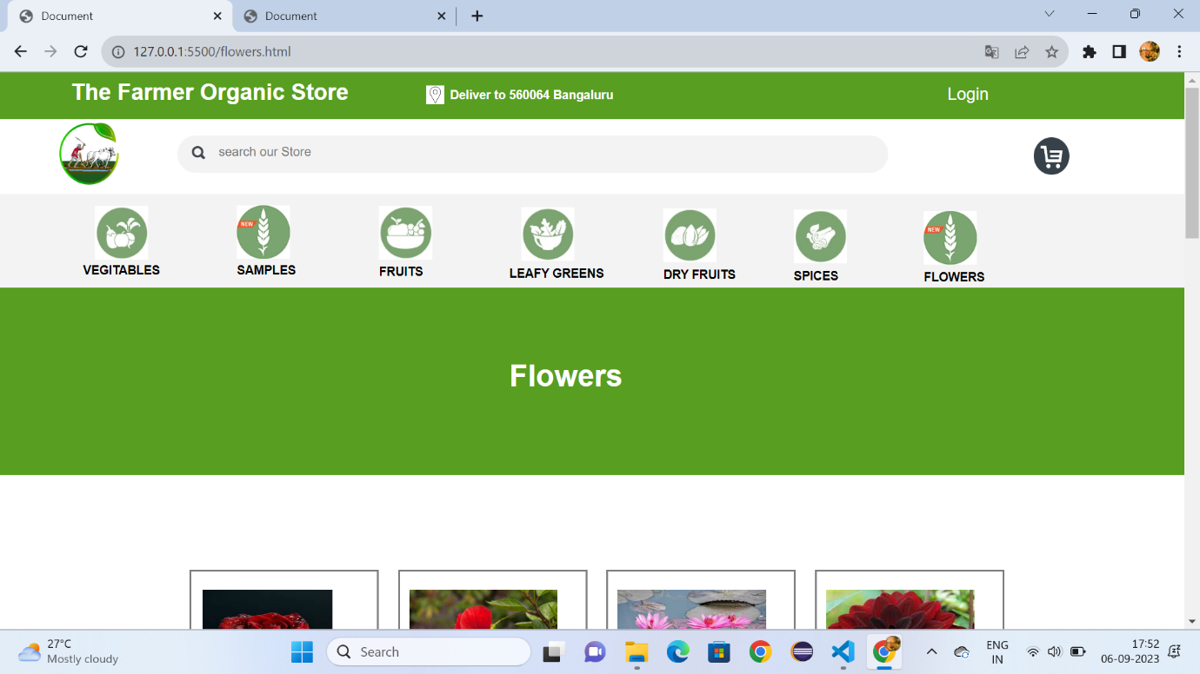

Fig:8.1

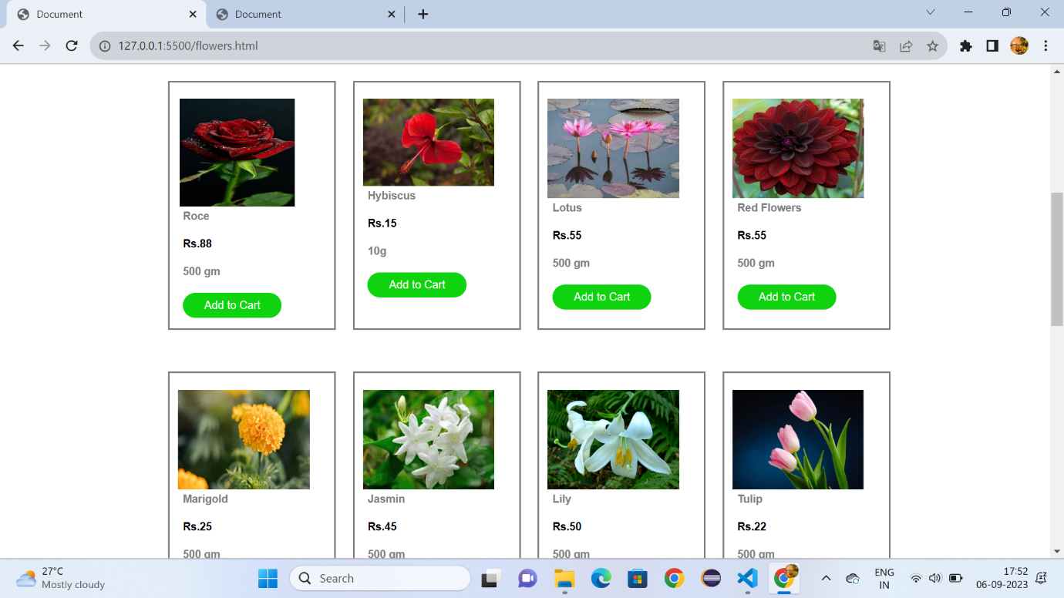

Fig:8.2

**Conclusion**

The Formers Organic Store project aims to establish a sustainable and profitable organic store under the Formers brand. This venture is driven by a commitment to providing high-quality organic products to the local community while promoting health-conscious and sustainable living practices. Throughout the project, the team will focus on various aspects, including market research, location selection (if applicable), online presence development, product procurement, branding and marketing, staffing and training, sustainability initiatives, and financial planning. However, it's important to acknowledge the constraints and challenges such as budget limitations, regulatory requirements, and market competition.